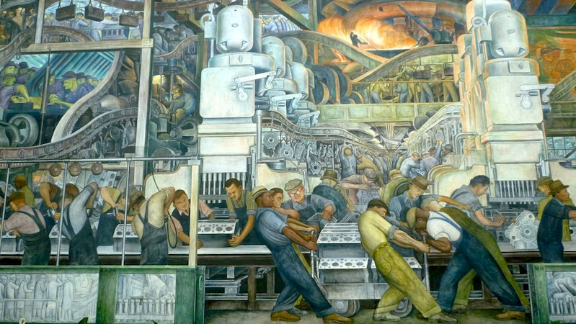

On this panel we can see a lot of men who are working at the assembly line
in a factory, probably a car factory. This work looks very difficult because
some workers are pulling very heavy trolleys.
The car factory employs a lot of men. /
In the car factory there is a lot of employment
actually the car industry is very properous. It is propbably a Ford factory.

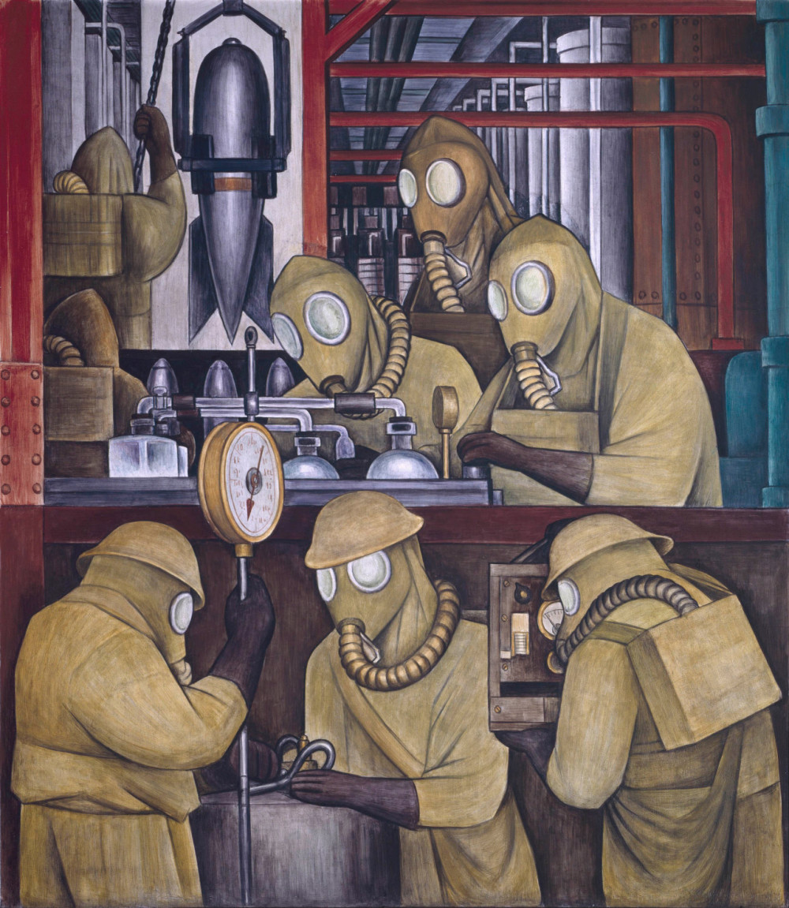

On this panel we can see some men who are wearing a special suit and
a gas mask to protect themselves because they are making bombs.
Their work is dangerous.
Rivera shows that industry is used for bad and dangerous things.



