Thursday, May 17th.

Detroit in the past | Detroit today.
active  attractive  jobs  motorcity  car industry  prosperous  important  assembly line  factories  make money  employment  recording  motown | Graffitis  abandonned  waste land  deliquency  sad  deteriorated  angry  vandalism  depressing  homeless  depressed  poor  economic crisis  dirty  drug  unemployment  debts  desperate  decline  brankruptcy  war zone  poverty

In the past , Detroit was prosperous and attractive.
Detroit made money thanks to the car industry.
Detroit used to be active.

« used to » + verb = habits in the past.

In Detroit there was a high rate employment
because there were a lot of factories.

Detroit used to be one of the most important cities.

A lot of people came to Detroit to make money
in the car industry which was properous.

Detroit used to be attractive thanks to the car industry which was prosperous.

Wednesday, 23rd May.

In the past Detroit was attractive actually the car industry was prosperous.

A lot of people made money actually they worked in car industry
which was very prosperous.

Detroit was a prosperous city thanks to the car industry
consequently a lot of people came to make money .

Before the crisis, Detroit was prosperous actually the city / it was active .

Habits in the past.
When he was young, Maxime used to play with pans
When he was at the primary school, Luc used to play with his pens
instead of working.
When they were young, Louna, Clara, Aurore ... used to say « pestacle »
instead of spectacle.
When she was young, Lea used to take her teddy with her everywhere.
When they were young, some of us used to suck their finger.
When I was young / When I was a baby I used to

Thursday, 24th May.

1 Today we have electricy while in the past people used to have candles or oil lamps .

2 Today we have the central heating but before people used to make fires / have wood stoves.
3 Nowadays people communicate a lot by mails or sms
but before people used to send / write letters.

4 Today we often take the car to move even for short distances
but before people used to cycle and walk a lot.

5 Today a lot of women work but in the past women used to stay at home.
6 Today it is difficult to find a job for some people but in the past it used to be easier to find a job.
7 Today children have toys made of plastic or electronic toys
but in the past children used to have wooden toys / toys made of wood.
8 Today most people have dish washers and washing machines
but in the past people used to hand wash.

9 Today we have Cds or Mps to listen to music
but some years ago people used to listen to music on the radio or on
vinyl records.

10 Today most people buy their vegetables in shops or at the supermarket
but before nearly everybody grew their vegetables in their gardens /
go to the market/ have a vegetable garden.

Quand elle était petite, kate avait l'habitude de courir dans les magasins.

Quand il était plus jeune, Patrick avait l'habitude d'aller en vacances
chez ses grand-parents / d'aller chez ses grand-parents pour les vacances.

Quand elle était bébé, Mary pleurait beaucoup.

Quand ils étaient plus jeunes, Steve et son frère avaient l'habitude de
se lever tôt pour traire les vaches (milk the cow).

Autrefois, les gens trouvaient du travail plus facilement.

Tuesday, May 29th.

Today, in Detroit people are sad, angry,poor,desperate, homeless and depressed

Today, in Detroit people suffer from vandalism, unemployment, poverty,
deliquency, the economic crisis.

Today, Detroit suffers from the economic crisis, poverty, vandalism.

People suffer from unemployment because a lot of factories have closed.

Wednesday, May 30th.

People suffer from unemployment : situation in the present.
A lot of factories have closed : justification of the situation in the present.

Have (in the present) + Vpp (past participle)

A lot of people are poor because they have lost their jobs.

Look at the illustrations and explain the situations by referring to the past.

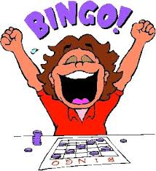
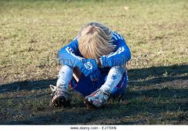

What can you see ? What has happened ?
1 2 3 4


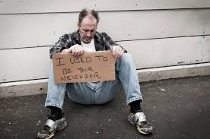

5 6 7 8

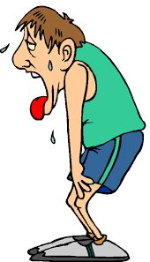

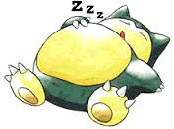
9 10 11 12

Look at the illustrations and explain the situations by referring to the past.
What can you see ? What has happened ?
1 2 3 4
5 6 7 8
9 10 11 12

1 She looks sad because she has received bad news.

2 He is sad because he has / they have lost the match.

3 They look happy because they have passed their exam.

4 She is very happy because she has won the bingo.

5 He is poor and homeless because he has lost his job.

6 He is happy because he has / they have won the match / he has scored.

7 She is happy because she has received good news /
she has had a promotion / she has been promoted.

8 She is slimmer because she has lost weight /
she has followed a diet so she has lost weight.

9 He is asleep because he has worked a lot / he has worked late.

10He is tired because he has run.

11 She is happy because she has slept well.

12 The cat is asleep because he / it has eaten a lot.

3) Explain the people's feelings and situations and the situation of Detroit today. What has happened ?
1 A lot of people are depressed and desperate
because they have lost their jobs.

2 There is a lot of delinquency in Detroit and a lot of people take drugs
because they have been desperate and depressed / they have lost hope.
3 A lot of people suffer from unemployment
because the car industry has closed.

4 A lot of people are poor
because the factories have closed consequently they have lost their jobs .
Because they have become homeless.
5 A lot of houses are deteriorated
because their inhabitants / their owners have left /
some people have vandalized them.

6 Detroit looks like a war zone or a waste land
because there has been a lot of vandalism.
7 Detroit has a high rate of unemployment
because a lot of factories have closed/ a lot of jobs have disappeared.
8 Detroit is in decline and it has important debts
because there has been an economic crisis and
the city has gone into bankruptcy.

Tuesday, June 12th.
8 Mile.
8 Mile is a road in Detroit which seperates the rich area and
the poor area. This road is 8 mile ( 12,6 km) long.

Eminem is the main character of the film.
He is famous in real life because he is a well-known rap singer.
Eminem and Detroit
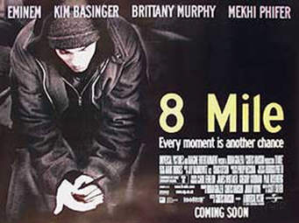
1) Who is Eminem? His name of birth.

His date and place of birth.

What is he known for ?
He is a famous rap singer

8 Mile by Curtis Hanson (2002) is a film inspired by Eminem's early life in Detroit with his mother before he became famous.
2) Watch the trailer and get information about :
The main character (le personnage prinicpal)  His family | He lives with his sister and his mother
Where does he live ?  (his environment / neigbourhood | He lives in a trailer. He lives in a ghetto, in a violent environment.
His work (his job) | He works in a factory .
His dream (his goal) | Become a famous rap singer  live in a big and beautiful house  live in a safe environment  escape poverty and his hostile environment
Expressing hopes or dreams :
Eminem probably hopes he will become a famous rap singer in the future .
wants to become ……..
dreams to become ……..
His dream is probably to become ……….
In the future / When I am older I hope I will
I want to
I would like to + verb
I dream to
my dream is to

Vocabulary help:
Nouns: 8 Mile Road - ghetto - factory (=usine) - battle - rap - trailer (caravane) - violence
Verbs: struggle (se battre contre des difficultés) - want - become successful - hope (espérer) - rap - do battles - win # loose

Thursday, June 14th.

The story of rap.
Written comprehension.
Read the document and find information.
The nature of the document | An extract from a magazine
The author of the document | Ruth Surridge and Kate Zemsteff
The title of the document | The story of rap
The origin of « rap » | DJ technique fromJamaica
Place of birth | New York ghettos
Subjects / themes of rap songs | Poverty violence drugs = problems of the ghettos
Rapers' style | Baggy trousers big Tshirts sports shoes
Rap is often linked with ……. (why?) | Violence actually rappers often fight against poverty and record companies encourage rappers to sing violent songs because it is good for their business.  Bling because it shows they have money.
2 rappers who died (names + circumstances) | Tupac Shakur and Notorious big were murdered.
Name of the most famous white rapper | Eminem

Beautiful.
Vocabulary help :

lately : in the last years
reach : find
get through : contact
reach out for : look for / search

slump : crisis
hump : obstacle
dump : litter
I took my bruises, took my lumps : I made great efforts / I tried very hard
outlet : un exutoire
I may be done with rap : maybe rap is finished for me

in my shoes : in my place
you ain't beautiful : you are not beautiful

General comprehension.

What do we learn in the introduction ? Who is « I » and who is « you » ?
« I » is Eminem « You » is his fans
Eminem was absent for a long time actually he didn't write songs and he didn't
give any concerts.

How does Eminem feel in the first lines of the first verse ? What about the last lines ?
Guess what has happened to him. What does he want to do ?

In the first lines Eminem feels depressed but in the last lines
we understand that he has decided to change, to take a new start in a word to react.
Maybe he has health or family problems, maybe he had lost inspiration,
maybe his albums didn't sell anylonger. In fact he felt blue because his best friend
was killed on 8 mile road.

Who is « I » in the chorus and who is « you » ?
« I » is Eminem and « you » is Detroit.

What is the connection between Eminem and Detroit ?
Eminem wants Detroit to react. Like him detroit was in a difficult situation
but they both must take a new start.

https://www.youtube.com/watch?v=lgT1AidzRWM

