Useful vocabulary to comment the video

dirty streets burnt

In the video we can see some broken houses, some homeless people.
Detroit is abandonned and poor even if there are rich districts.
There are a lot of black people.
There are damaged cars. There is unemployement.
We can see some people taking drugs.
In Detroit there is snow in winter because it is cold however some people sleep
or live in the street.
On some buildings, there are graffitis.
A lot of houses are destroyed or deteriorated.
Some buildings are in ruins.

Detroit in the past | Detroit today / nowadays
Active  jobs  Motorcity  make money  important  attractive  prosperous  employment  economic crisis  recording  factories  strikes  car industry  riots  assembly line  motown  bankruptcy  debts | Poverty  graffitis  vandalism  drugs  dirty  sad  poor  homeless  abandonned  war zone  unemployment  depressing  deteriorated  desperate  homelessness  empty  delinquency  angry  dilapidated  depressed  decline  waste land  debts  bankruptcy

Monday, April 3rd.

Detroit in the past was an important city because it was active
actually there was a big car industry.

In the past, Detroit was attractive actually this city was prosperous.
The car industry was important
consequently there was a lot of money in Detroit.

The Motorcity was in economic crisis consequently a lot of people lost
their jobs.

Detroit was active because the car industry was prosperous.
Detroit used to be active because the car industry used to be prosperous.

In Detroit there were a lot of prosperous car factories.

In the past, Detroit was active because there were a lot of jobs,
high employment in the car industry.

Detroit was active because the car industry was prosperous.
Detroit used to be active because the car industry used to be prosperous.

Remark : used to + verb expresses habits in the past
but it is finished in the present.

When I was young, I used to

Complete the sentences using « used to + verb ».

1 Today we have electricy while in the past people used to have oil lamps or candles.

2 Today we have the central heating but before people used to have wood stoves.
3 Nowadays people communicate a lot by mails or sms but before people used to write letters.

4 Today we often take the car to move even for short distances but before
people used to walk a lot / used to move by bike.

5 Today a lot of women work but in the past women used to stay at home.
6 Today it is difficult to find a job for some people but in the past it used to be easier to find a job.
7 Today children have toys made of plastic or electronic toys
but in the past children used to have wooden toys.
8 Today most people have dish washers and washing machines
but in the past people used to hand wash.

9 Today we have Cds or Mps to listen to music
but some years ago people used to listen to music on the radio.
People used to have vinyl records.

10 Today most people buy their vegetables in shops or at the supermarket but before nearly everybody used to garden / used to grow vegetables in their gardens.

Friday April 7th.

People's feelings and situations.
Poverty homeless angry sad dirty desperate despressed

unemployment poor drugs deliquency depressing debts

graffitis vandalism.

People suffer from poverty, deliquency and homelessness.

People are sad, angry, poor,dirty, depressed and desperate
because

People are dirty because they live in the street.

People are sad because they are desperate.

People are homeless because they are unemployed.

People are depressed because the city has gone
into brankruptcy because there was an economic crisis.

People are poor actually they don't have money because
there are no jobs.

Tuesday 25th April.
The situation of Detroit

Today Detroit suffers from poverty
because there was an economic crisis
consequently a lot of people have lost their jobs.

In Detroit a lot of buildings and houses are abandoned.

A lot of houses are deteriorated
actually / because their inhabitants have left.

A lot of houses are deteriorated
actually some people have broken the windows.

Have + verb in the past participle is used to
explain a situation in the present.
We use the past to explain the present.

Remark : Vpp = 3rd form of the irregular verbs or verb + ed

A lot of people are poor because

A lot people suffer from unemployment because

Detroit looks like a war zone or a waste land because

Monday may 15th .

In the past there was a lot of money .
In the past there was a prosperous car industry.
In the past there was a lot of employment.

In the past there were jobs.
In the past there were a lot of prosperous factories.
In the past there were a lot of rich people .
In the past there were beautiful and big houses.

Today there is a lot of unemployment.
Today there is a lot of delinquency.
Today there is a war zone and a waste land.
Today there is a lot of vandalism.
Today there is a high rate of poverty.
Today there is a high rate of homeless.

Today there are a lot of deteriorated and abandoned houses .
Today there are a lot of debts.
Today there are a lot of homeless people .
Today there are a lot of graffitis on the walls.

Their = leur(s)
They're = they are ils / elles sont

Tribute to Detroit.

Pay tribute to

It is the trailer of « 8 mile ». 8 mile is a road which
separates Detroit in 2 parts ( the north and the south).
The road is approximately 12.8 kilometers long.

Friday May 5th.

1 She looks sad because she has lost her job / she has had bad news / she has received bad news.

2 He is sad because they have lost the match.

3 They are happy because they have passed their exam.

4 She is happy because she has won.

5 He is desperated because he has lost his house.

6 He looks very happy because he has scored.

7 She is happy because she has finished her work.

8 She is much slimmer because she has followed a diet.

9 He is sleeping on his desk because he has worked a lot / late.

10 He looks exhausted (very very tired) because he has run a lot.

11 She feels good because she has slept very well.

12 He is asleep because he has eaten too much / a lot.

Explain the people's feelings and situations and the situation of Detroit today. What has happened ?
1 A lot of people are depressed and desperate because they have lost a lot of money.

2 There is a lot of delinquency in Detroit and a lot of people take drugs because
a lot of people have lost all they had.
3 A lot of people suffer from unemployment because a lot of factories have closed...........................

4 A lot of people are poor because they have lost their jobs.
5 A lot of houses are deteriorated
because a lot of people have left the city and have abandoned their houses..............
6 Detroit looks like a war zone or a waste land
because the inhabitants have broken or have deteriorated some places.............................
7 Detroit has a high rate of unemployment because a lot of factories have close.
8 Detroit is in decline and it has important debts because
the city has been in economic crisis / the city has gone into bankruptcy.
Friday May 12th ;

Before the crisis, there was

Before the crisis, there were

Today, there is

Today, there are

Tuesday, May 16th .

The main character in « 8mile » is Eminem.

In the movie he lives in a small trailer with
his little sister and mother.

In his neighbourhood, there aggressive and
violent people. There are a lot of people
who take or deal drug.
He lives in a hostile environment
so he hast to / he must struggle everyday.

He works in factory

Tuesday may 30th ;

Eminem is the main character of the movie .
Eminem is a rapper.
His neighbourhood is dangerous, violent...

Eminem works in a factory .

Eminem lives in a ghetto in Detroit .
Eminem lives in a trailer with his sister and his mother.

His dream/ his goal.

Eminem wants to become successful with rap.
Eminem dreams to leave his guetto and
to become a successful singer.
His goal is to do rap battles.
Eminem hopes Detroit will become prosperous again.
Eminem hopes he will have a new and better life.
His dream is to restore the hope of
the inhabitants of Detroit.
The dream of Eminem is to become a rap singer
to leave poverty and to help his family and his friends.

His dream is to escape poverty
and the violence of his neighbourhood.

Name :

1 Re-write the sentences in the past (preterite). / 4
1 Ted often fights with his brother.
2 Fred often breaks his glasses when he is at school.
3 Steve always has a cold in winter.
4 Mary always buys clothes when she goes shopping with her sister.

5 Alison often sleeps at her best friend's when they are on holidays.

2) Add the missing forms. / 6

Base from | Preterite | Past participle | French
 |  |  | apporter
Catch
Teach
 |  |  | oublier

Name :

1 Re-write the sentences in the past (preterite). / 4
1 Ted often fights with his brother.
2 Fred often breaks his glasses when he is at school.
3 Steve always has a cold in winter.
4 Mary always buys clothes when she goes shopping with her sister.

5 Alison often sleeps at her best friend's when they are on holidays.

2) Add the missing forms. / 6

Base from | Preterite | Past participle | French
 |  |  | apporter
Catch
Teach
 |  |  | oublier

Flash test (irregular verbs).

Name :

1 Re-write the sentences in the past (preterite). / 12

1 It is so cold that the sea freezes.
2 Kate and her husband are ohotographers. They often make photos in black and white.
3 kerry teaches the guitar in a youth club.
4 A lot of people steal because they don't have food.

5 Jerry's cat is very fearful (peureux) so it often hides under the furniture.

6 John often bets at the casino but he often loses a lot of money..

7 At week-ends Paul goes to the beach with his friends.

2) Note down the verbs in the correct column and complete the grid. / 8

rode got grown catch draw shook known sleep

Base from | Preterite | Past participle | French

The Detroit Institute of Arts was inaugurated in 1885.

Diego Rivera was a Mexican painter
who lived between 1886 and 1957.
who was born in 1886 and he died in 1957.

He did / made a fresco of 27 panels for the DIA.
The title of the fresco is / the fresco is entitled « Detroit Industry Mural ».
It took Diego Rivera 8 months to make it.

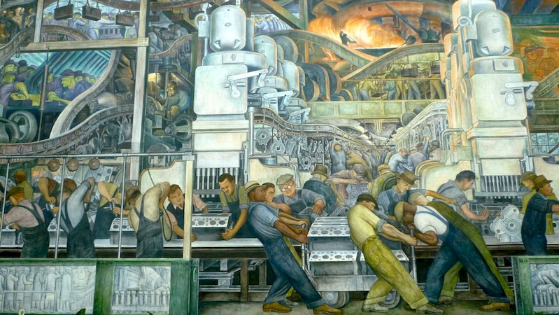

On this panel, we can see a lot of men who are working at the assembly line
in a car factory. They look tired. At the top there is a fire.

We understand that the work is difficult because it is probably hot
so they suffer from the heat.

The message is that working is the car industry is difficult and exhausting,
only men work there and a lot of people work for the car factories.

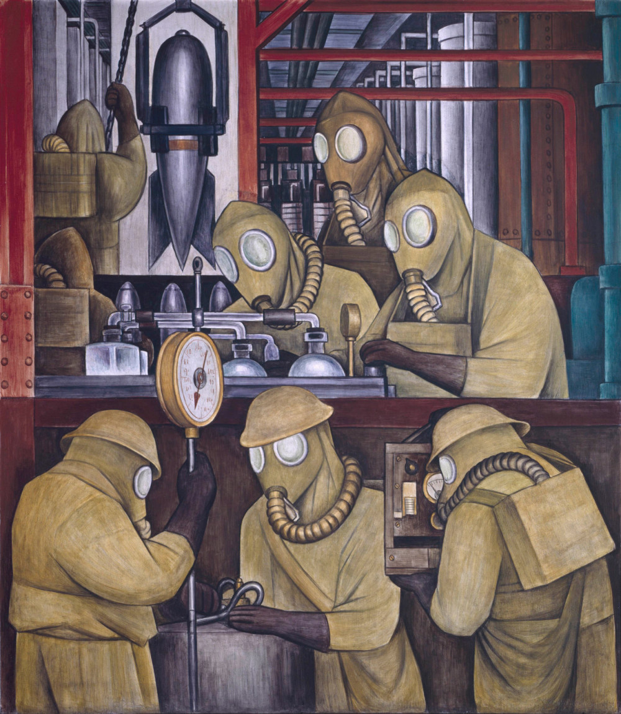

We can see 8 men in overalls, they have a mask to protect their faces from
a toxic product.
They are making a bomb.

We understand that their work is dangerous.

Diego Rivera denounces the use of industry to make bombs.

