Anaylise the soundtrack of the film.
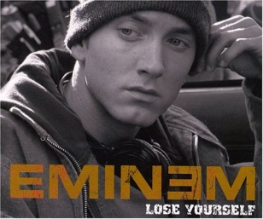
Lose Yourself
[Intro]
Look, if you had one shot, or one opportunity
To seize everything you ever wanted, in one moment
Would you capture it or just let it slip?
[Hook]
You better lose yourself in the music
The moment, you own it, you better never let it go
You only get one shot, do not miss your chance to blow manquer/rater
This opportunity comes once in a lifetime, yo

In your own words, explain the message of the song.

