
Baltimore Magazine

National Geographic

Detroit: The Most Exciting City in America?

New York Times

Detroit’s Greener Side | Detroit Urban Farming

visitdetroit.com

Turning Derelict Buildings into

an Urban Farm in Detroit

The Michigan Urban Farming Initiative produces thousands of pounds

of organic produce each year in Detroit's North End, using existing infrastructure

and encouraging the local community to participate.

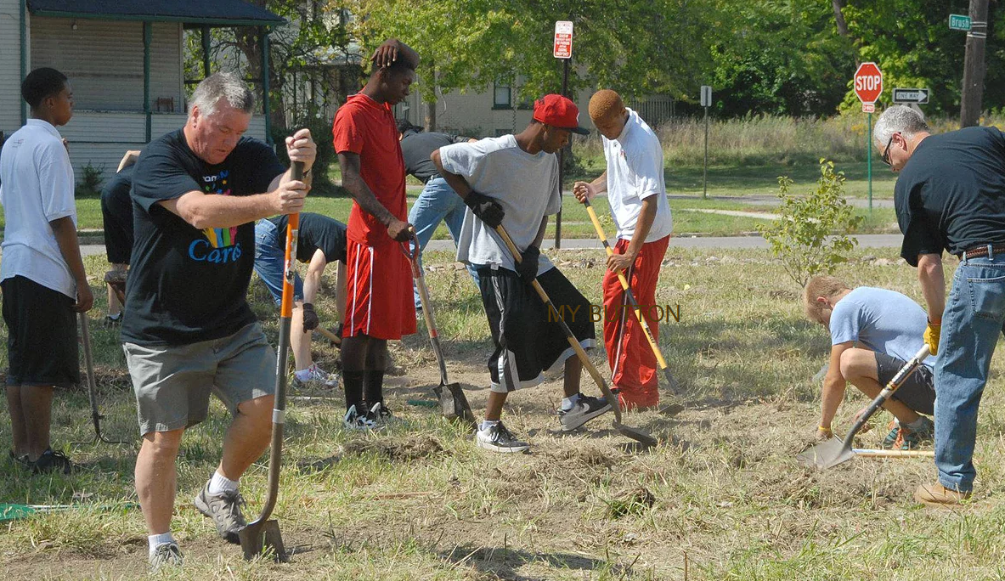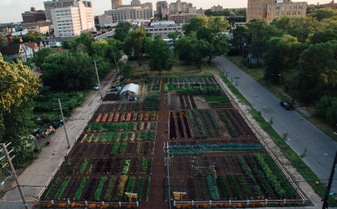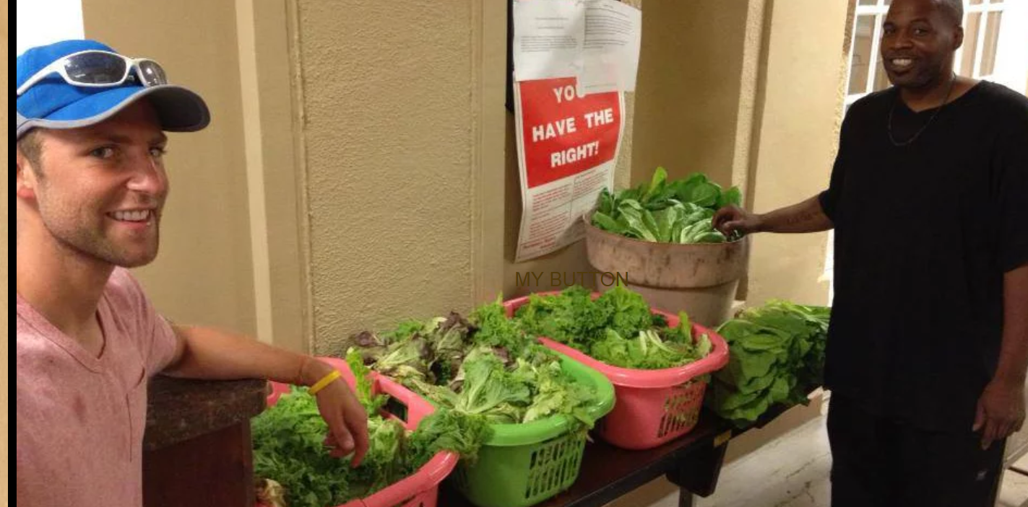

miufi

Invigorating Detroit’s Public Art Renaissance Seen Magazine

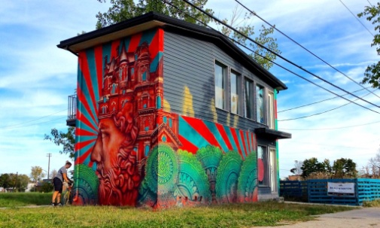 a mural

