Vocabulary. What is the English for ….. ?

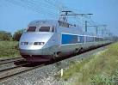
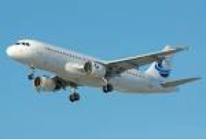
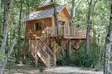
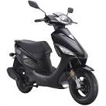



Write about your experience from the illustrations.
( Check the past participle forms of the verbs in your list !! )

