Choose one illustration

- describe the people (physical appearance)
- imagine the people's lives and habits : activities, food habits
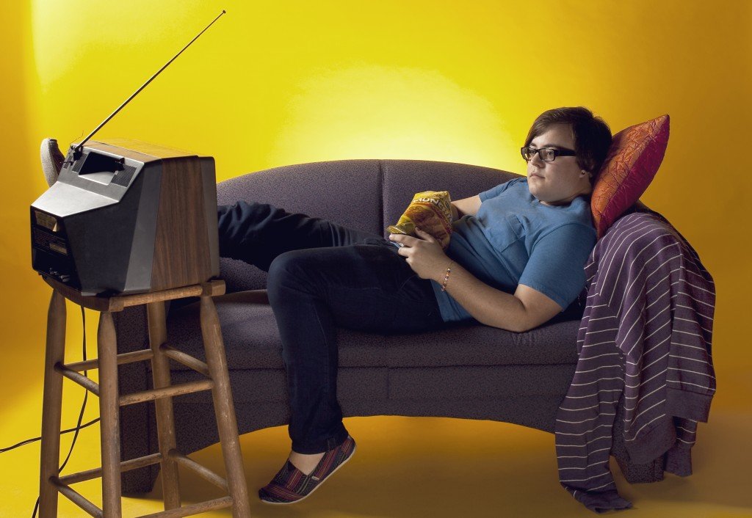
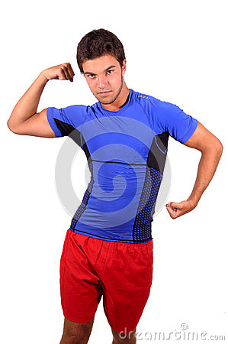

Picture 1 | Picture 2
Physical appearance : | Physical appearance :
Habits (activities) :  Food habits : | Habits (activities) :  Food habits :

Vocabulary help : fat slim fit overweight active lazy energetic practise sport sofa run watch TV crisps healthy food vegetables hamburgers

a healthy diet food with no fat and sugar fast food cakes dairy products food with sugar and fat bad food habits eat a lot chocolate

