Monday January, 15th.

visit my grandparents
go shopping
sleep late in the morning
relax
go to the cinema
get up late
watch TV
listen to music
play games
pack my presents
play video games
decorate the table
play with my dog
go to the restaurant
decorate my christmas tree and my house
go out with my friends
do my homework
go to the mountain
play in the snow

Write about the different people's holidays.

 | Peter | Sandra | Tony and his brother
sleep late in the morning |  | V | V
decorate the house | V
do his / her homework | V | V
visit his / her / their grandparents |  |  | V
go shopping |  | V
go to the cinema with friends | V |  | V

Peter decorated the house, he did his homework and he went to the cinema with friends.

Sandra slept late in the morning, she did her homework and she went shopping.

Tony and his brother slept late in the morning, they visited their grandparents and
they went to the cinema with friends.

Write about the different people's holidays.

 | Peter | Sandra | Tony and his brother
sleep late in the morning |  | V | V
decorate the house | V
do his / her / their homework | V | V
visit his / her / their grandparents |  |  | V
go shopping |  | V
go to the cinema with friends | V |  | V

Write about the different people's holidays.

 | Peter | Sandra | Tony and his brother
sleep late in the morning |  | V | V
decorate the house | V
do his / her / their homework | V | V
visit his / her / their grandparents |  |  | V
go shopping |  | V
go to the cinema with friends | V |  | V

Peter decorated the house, he did his homework and he went to the cinema with friends.

Sandra slept late in the morning, she did her homework and she went shopping.

Tony and his brother slept late in the morning, they visited their grandparents and
they went to the cinema with friends.

Write about the different people's holidays.

 | Peter | Sandra | Tony and his brother
sleep late in the morning |  | V | V
decorate the house | V
do his / her / their homework | V | V
visit his / her / their grandparents |  |  | V
go shopping |  | V
go to the cinema with friends | V |  | V

Jerry's holidays
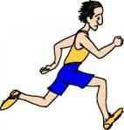
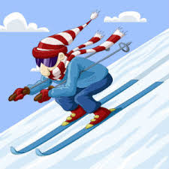

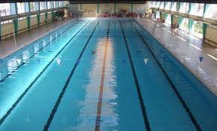





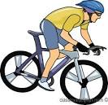

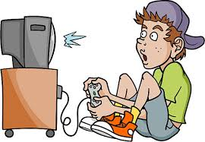

Kerry's holidays.

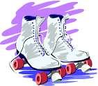
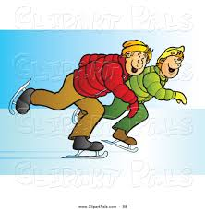
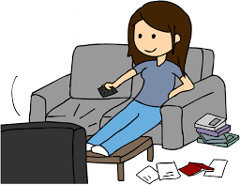


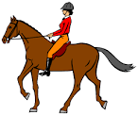

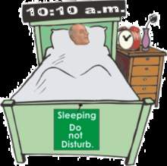

Name :
Write from the information in the grid about the last holidays. / 10 pts

 | Helen and her sister | Patrick
cinema with friends |  | V
late in the morning | V
shopping | V
homework | V
grandparents |  | V
video games |  | V

Helen and her sister slept late in the morning, they went shopping and they did their homework.

Patrick went to the cinema with friends, he visited his grandparents and he played video games.

Remark :

Armand celebrated Christmas at his uncle's.
Lucas celebrated Christmas at his grandparents'.
Maxime celebrated Christmas at home.

Evan went to his grandparents' for Christmas.

Name :
Write from the information in the grid about the last holidays. / 10 pts

 | Helen and her sister | Patrick
cinema with friends |  | V
late in the morning | V
shopping | V
homework | V
grandparents |  | V
video games |  | V

________________________________________________________________________________
________________________________________________________________________________
________________________________________________________________________________
________________________________________________________________________________
________________________________________________________________________________
________________________________________________________________________________

Wednesday, Januray 17th.

Christmas day and Christmas Eve.

verbs | nouns | adjectives
prepare  open  set / set  drink / drank  eat / ate  buy / bought  decorate  make / made  pack  get / got  do / did  cook  give / gave  listen  have / had  dance  go / went  visit  wake up / woke up  play  bring / brought  be / was were | Presents  turkey  money  meal  soda  food  cake  candles  toast  christmas tree  table  champagne  music  morning  christmas pudding  family  seafood  fish  duck  potatoes  shopping  grandparents  games  video games | Good  beautiful  happy  delicious  late  festive  nice  big  funny

- Before Christmas Lola went shopping to buy some presents
for her family.
- Hanae decorated her house and it was very beautiful.
- Lucas prepared a big turkey.
- Armand got up late.
- Gabrielle ate Christmas pudding / Christmas log, it was delicious.
- Emma helped her mother and her grandparents to decorate
the table.
- Evan went to his grandparents' for Christmas / Evan celebrated
Christmas at his grandparents'.
- On Christmas Day, Margaux opened her presents and
she was happy.
Sebastien's uncle gave him money for Christmas.
- Hanae celebrated Christmas at home with her family
and her grandparents.

Christmas presents.

Sarah had clothes by her aunt.
Maxime had a desk lamp by his mother.
Lylou had a pair of shoes by her grandfather.
Margaux is very happy because she had money by her uncle
and a jacket by her parents.
Samantha is very happy because she had the overboard
she really wanted by her mother.

Name :

Complete the grid.

infinitive | preterite | french
begin
bring
 |  | acheter
choose
 |  | venir
do
drink
make
wake up
 |  | téléphoner
 | left

Complete with a verb in the past.

1 Steve ……………... his parents a box of chocolates for Christmas.

2 Peter …………….. very happy because he …………….. the mobile phone he really …………….. by his parents.

3 Kerry …………….. Christmas at her uncle's with her family and her grandparents.

4 James …………….. his Christmas presents under the Christmas tree when he …………….. on Christmas Day.

5 John …………….. shopping the day before Christams Eve.

6 Harry and his brother …………….. very happy because they …………….. the billiard they really ……………..

7 During the holidays, Alison …………….. at the restaurant twice (2 fois).

8 For Christmas dinner, Elizabeth…………….. the log.

9 During the holidays, David …………….. late in the morning.

10 Kate and her family …………….. their presents on Christmas Day after the meal.

11 For Christmas, Becky …………….. her brother's portrait for her parents.

12 On New Year's Day, Philip …………….. his grandparents to wih them a happy new year.

Christmas in other countries.

Read the documents and note down in formation in the grid.

 | Australia | The United Kingdom | New Zealand | South Africa
weather  season | Sunny / hot  summer | Rarely snow (every 4 or 5 years)  cold | hot / sunny  middle of summer | a lot of sun  summer
decorations | Xmas tree  xmas lights 1st dec (competion between neighbour) | -Xmas tree  -xmas lights  -flowers,candles on the tables  -homes and buildings  -Oxford street (London) most famous lights  -Mistletoe, holly and icy to decorate  -villages lights switched on by a famous person | In big towns xmas lights shows  xmas tree | Xmas tree  flowers in bloom
Santa Claus | Kangaroos  less hot clothes | Letters in the fireplace xmas fathers reads the lists in the smoke  mince pies and brandy for Santa | Carrots for the reindeers  beer and pineapple for Santa  jandals + All Blacks Rugby t-shirt | Stockings out for Santa
Christmas day :  -activities  - meal  - presents | Watch xmas carol singing on TV  festivals parades fireworks  BBQ seafood cold dinner xmas crackers | Roast turkey vegetables bacon sausages cranberry sauce bread sauce xmas pudding brussel sprouts  tifle  xmas crakers  open presents with family | The beach  parades decorated floats, bands,marching girls  BBQ xmas pudding ice cream  hot fruit pudding with custard ;  soft drinks , jelly  the most popular present : jandals  open presents before the xmas lunch | Camping  have a swim  play games visit family  a trip in the countryside  morning church service  turkey, duck, roast beef, mince pies, suckling pig rice with raisins and vegetables  Malvea pudding :( African dessert)  xmas crakers
boxing Day  (26th dec) | Visit friends and family + have BBQ on the beach  yacht race | Old custom  a holiday |  | Public holiday  people go out
others | Summer holidays | The Queen's xmas message at 3 on xmas Day on TV. | time on the beach  + camping | School closed  go camping

Write about your last holidays.
In your work you will :
- write about your activities before Christmas, between Christmas and New Year's Eve and after January 1st.
- write about your Christmas ( Christmas Day, your presents and the traditions on Christmas Day and during the Christmas season in the UK or in Australia).
- use 14 different verbs in the past ( minimum 7 irregular verbs)
Name :  Je suis capable de parler de mes vacances de noël et de donner des informations sur noël dans un autre pays | / 30 coef 2
Mes activités avant noël, entre noël et la Saint Sylvestre et après le 1er janvier | 0 1 2 3 4 5 6
Le jour de noël ( où, avec qui, mes cadeaux) | 0 1 2 3
Contenu culturel (noël dans un autre pays) | 0 1 2 3 4 5 6 7 8 9 10
Je suis capable de m'exprimer au passé | 0 1 2 3 4 5 6 7
Expression compréhensible magrè des erreurs de langue | 2 3 4 5
Expression difficilement compréhensible | 0 1
____________________________________________________________________________________
____________________________________________________________________________________
____________________________________________________________________________________
____________________________________________________________________________________
____________________________________________________________________________________
____________________________________________________________________________________
____________________________________________________________________________________
____________________________________________________________________________________
____________________________________________________________________________________
____________________________________________________________________________________
____________________________________________________________________________________
____________________________________________________________________________________
____________________________________________________________________________________
____________________________________________________________________________________
____________________________________________________________________________________
____________________________________________________________________________________
____________________________________________________________________________________
____________________________________________________________________________________
____________________________________________________________________________________

Complete the sentences with a verb to describe the traditions or habits on the occasion of Christmas or during the Christmas period.

1 In the UK, people ………………………… the Queen's speech on TV.
2 In New Zealand, Santa ………………………… an All Blacks' Rugby T-shirt.
3 In Australia, people often ………………………… a BBQ on Christmas Day.
4 In the UK, the Queen always ………………………... a Xmas message on Xmas Day at 15.00.
5 For Xmas, people often ………………………... jandals in New Zealand actually it is the most famous present.
6 During the Xmas season, there ………………………… a lot of lights in the streets in most countries.
7 In the UK, people ………………………… their houses with mistletoe, holly and ivy.
8 In Australia, Santa ………………………… less hot clothes.
9 In the UK, children ………………………… their letters to Santa into the fireplace.
10 In South Africa, people ………………………… rice with raisins.
11 In Australia, people ………………………… the Xmas lights at the beginning of December.
12 In Australia, people often …………………. Xmas carol singing on TV.
13In South Africa, the schools ……………….. during the Xmas season.
14 In New Zealand, there ……………….. often parades and marching girls on Xmas Day.
15 In New Zealand, people ……………….. their presents on Xmas Day before lunch.
16 In the UK, it rarely ……………….. on Xmas Day, only every 4 or 5 years.
17 In New Zealand,, children ……………….. beer and pineapple for Santa.
18 In Australia, Santa ……………….. kangaroos instead of reindeers.
19 In London, a famous person ………………. the lights in Oxford Street.
20 In South Africa, people ……………….. a Xmas morning church service.
21 In some countries, people ……………….. crackers on Xmas Day.

Complete the sentences with a verb to describe the traditions or habits on the occasion of Christmas or during the Christmas period.

1 In the UK, people ………………………… the Queen's speech on TV.
2 In New Zealand, Santa ………………………… an All Blacks' Rugby T-shirt.
3 In Australia, people often ………………………… a BBQ on Christmas Day.
4 In the UK, the Queen always ………………………... a Xmas message on Xmas Day at 15.00.
5 For Xmas, people often ………………………... jandals in New Zealand actually it is the most famous present.
6 During the Xmas season, there ………………………… a lot of lights in the streets in most countries.
7 In the UK, people ………………………… their houses with mistletoe, holly and ivy.
8 In Australia, Santa ………………………… less hot clothes.
9 In the UK, children ………………………… their letters to Santa into the fireplace.
10 In South Africa, people ………………………… rice with raisins.
11 In Australia, people ………………………… the Xmas lights at the beginning of December.
12 In Australia, people often …………………. Xmas carol singing on TV.
13In South Africa, the schools ……………….. during the Xmas season.
14 In New Zealand, there ……………….. often parades and marching girls on Xmas Day.
15 In New Zealand, people ……………….. their presents on Xmas Day before lunch.
16 In the UK, it rarely ……………….. on Xmas Day, only every 4 or 5 years.
17 In New Zealand,, children ……………….. beer and pineapple for Santa.
18 In Australia, Santa ……………….. kangaroos instead of reindeers.
19 In London, a famous person ………………. the lights in Oxford Street.
20 In South Africa, people ……………….. a Xmas morning church service.
21 In some countries, people ……………….. crackers on Xmas Day.

