School in the USA.
American education system.

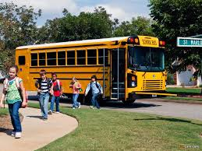
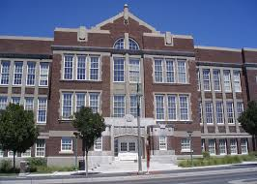
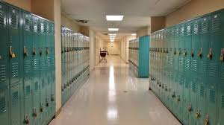
1) Write the different levels of the American education system in the correct order.

Elementary school kindergarten middle school daycare high school pre-school

2) Answer the questions.
1 Where do you go when you are a baby up to the age of 1 or 2 ? What is the equivalent in French ?
2 Which school do you attend when you are 5 years old in America ? Are you obliged to go there ?
3 How many grades are there at the primary school? What is the other name of the primary school ?
4 What is the equivalent of « collège » in America ? How many grades are there ?
5 What is important for teenagers at the age of 16 in America ?
6 What is surprising in the US education system ?
3) Complete the sentences.
1 When you are in 9th grade you go to …........... school, the equivalent in French is …...................... In this school, there are …......... grades.
2 In 9th grade you are a …....................., in 10th grade you are a …....................., in 11th grade you are a …..................... and in 12th grade you are a ….....................
3 You must go to school up to the age of …........
The pledge of allegiance.

1* Look at the illustrations and say what you can see. Who ? Where ? What ?

Where ? At school. In the USA. We can see the American flag.

Who ? Some pupils.

What ? They are singing. They are standing. They are looking at the American flag.

The pupils' attitude : The look serious. They are concentrated. It seems to be an important moment.

« The star-spangled banner » (la bannière étoilée) is the national anthem, but here it is different. They are saying the « Pledge of allegiance »

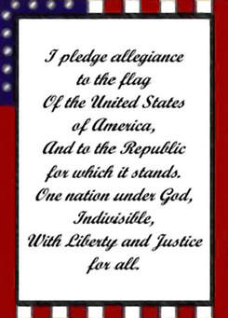
The pledge of allegiance.

I promise to be sincere, loyal and faithfull to the flag.

The flag is the emblem of the country.

I swear (I promise) to be faithfull to the government and to the republic represented by the flag.

The nation is indivisible.

Everybody can live in liberty / freedom and justice.

2* Oral comprehension.

- Listen and take notes.
- Classify the words you have noted down in the grid.

Where ? | When ? | What ? | Why ? / What for ? | After the pledge of allegiance.

Vocabulary
1 crèche :
2 maternelle :
3 collège :
4 lycée :
5 à l'âge de ….. :
6 quand on a 16 ans :
7 fréquenter une école :
8 le drapeau américain :
9 le cœur :
10 se lever :
11 un adolescent :
12 regarder quelque chose :
13 obligatoire x2 :
14 un niveau :
15 d'un état à l'autre :
16 la loi :
17 varier :
18 le début de la journée d'école :
19 tous les jours:
20 respecter :
21 prier :
22 les gens qui sont morts pour le pays :
23 les victimes de guerre :

Mental cards :

US education system

pledge of allegiance

Name :

Vocabulary / 10

1 maternelle :

2 collège :

3 lycée :

4 à l'âge de ….. :

5 quand on a 16 ans :

6 fréquenter une école :

7 le drapeau américain :

8 le cœur :

9 se lever :

10 un adolescent :

11 regarder quelque chose :

12 obligatoire x2 :

13 un niveau :

14 d'un état à l'autre :

15 la loi :

16 varier :

17 le début de la journée d'école :

18 tous les jours:

19 prier :

20 les gens qui sont morts pour le pays :

21 les victimes de guerre :

The US education system : final task.

1) Write the different stages of the US education system in the correct order. / 1 (bonus)
pre-school / day care middle school high school kindergarten elementary school

1____________________ 2 ____________________ 3____________________
4____________________ 5____________________
2) Your parents have been promoted but all the family had to move to the USA. Now you are an american pupil.
Write a paragraph for your former school blog about the US education system.
In your work you will
- give information about kindergaten, primary school, middle school and high school.
- explain what is surprising in the US education system.
- give information about the Pledge of Allegiance.
- use the important words of vocabulary studied in class.
Je suis capable de parler du système éducatif aux USA.  Etre capable de m'exprimer en langue étrangère. | Mark : / 30      
Mettre en œuvre les capacités essentielles. D2 1.3
Comprendre des consignes et les respecter. D2 1.2
Je donne différentes informations sur :  kindergarten  primary school  middle school  high school | 0 1 2  0 1 2  0 1 2  0 1 2 3 4
Je dis ce qui est surprenant dans le système éducatif aux USA | 0 1 2
Je donne des informations sur The Pledge of Allegiance | 0 1 2 3 4 5 6
J'utilise du vocabulaire nouveau travaillé en classe | 0 1 2 3 4
Mon expression est compréhensible malgré | de rares erreurs 8 7  quelques erreurs 6 5  des erreurs fréquentes 4
Mon expression est difficilement compréhensible | parfois 3 2  souvent 1 0
Mon travail n'est pas soigné et je fais de nombreuses fautes l'orthographe | -1 -2

Final task : correction.

From the age of 5 to the age of 6 children go to kindergarten.
It is not mandatory everywhere in the country actually
the law varies. It is the equivalent of « maternelle » in French.

At the age of 7, children start primary school.
They attend primary school up to the age of 12.
The US education system is organised in grades.
At the primary school, there are 6 grades (from 1st grade to 6th grade).

Then, when they are 13, children go to middle school
for 2 years. They are in grades 7 and 8.

Finally teenagers attend high school from the age of 15
to the age of 18. There are 4 grades. When you are in grade 9
you are a freshman, in grade 10 you are a sophomore and you can drive because you are 16, in grade 11 you are a junior and to finish
in grade 12 you are a senior.

In the USA, it is surprising because the law varies
from state to state. Actually for example kindergarten is
mandatory in some states and not in others and
the grades are organised differently.

In the USA, people say the Pledge of Allegiance everyday
at the beginning of the school day. They stand up, they put their right hands over their hearts and they look at the American flag.
People say the Pledge of Allegiance to honor the flag of America.
Then, they respect a moment of silence to pray for
the people who died for the country and
for the victims of war. It is a very important moment.

