The computer.

The computer is a worldwide invention. It was invented in
the mid-twentieth century.
It is used by millions of people in the world everyday. It is
very helpful for different reasons (purposes) so the computer
has a lot of positive points (advantages) but also a lot of
negative points (disadvantages).

Advantages | Disadvantages
- sell products all around the world  - create and test new products  - save natural ressources / limit the use of paper and pencils  - store a big quantity / a great amount of data  - fast / save time and useful  - some new jobs are created  - work more easily  - store a lot of important data in a small space  - solve problems faster  - communicate more easily  - good for old people who can’t go out (to buy or pay online) | - a lot of people lose their jobs  - transform our cities and our lives  - a lot of shops close because of shopping online  - use a lot of electricity and energy in general  - some people get addicted because a lot of time  surfing the net  - impossible to communicate with other people if no internet  -bad for the eye sight / eye sight problems  - a lot of students copy  - bad for the social life  - a lot of money = expensive  - computer for no reason = waste of time  - parental control necessary  - less sport  - a lot of time and electricity

Parental control is necessary because the net can be risky or
dangerous for children actually some ads or video are not adapted
to their ages.

The computer is bad for the eye sight because some people spend
a lot of time / too much time on their computer,
surfing the net for example.

The computer is bad for the social life / damages the social life
people don’t go out and they don’t see their friends or families.

People spend a lot of time surfing the net.
Spend time + ving = passer du temps à faire quelque chose

Be / get addicted to = être / devenir accro à quelque chose

Vocabulary check point

surf on the net
parental control
shopping online
buy online
eyesight
worldwide
data
files
useful
helpful
spend time +ving
purpose
a waste of time
waste time
get addicted to / be addicted to
expensive
disk drive
save time
fast / faster
easy / easier / more easily
store
a great amount of = a big quantity of
because of
thanks to
natural ressources

Name :
1) Vocabulary . / 7
acheter en ligne :

la vue :

une donnée :

utile :

une perte de temps :

cher (coûteux) :

économiser du temps :

plus facile :

plus facilement :

stocker :

une grande quantité de (* a big quantity of) :

à cause de :

grâce à :

les ressources naturelles :
2) Grammar . / 8
1 John est accro aux jeux vidéo.
2 Kate est accro à son portable.
3 Les gens deviennent accro à internet.
4 Betty passe son temps à dormir.
5 Les adolescents passent beaucoup de temps à surfer sur le net.
6 Tom passe son temps à travailler.

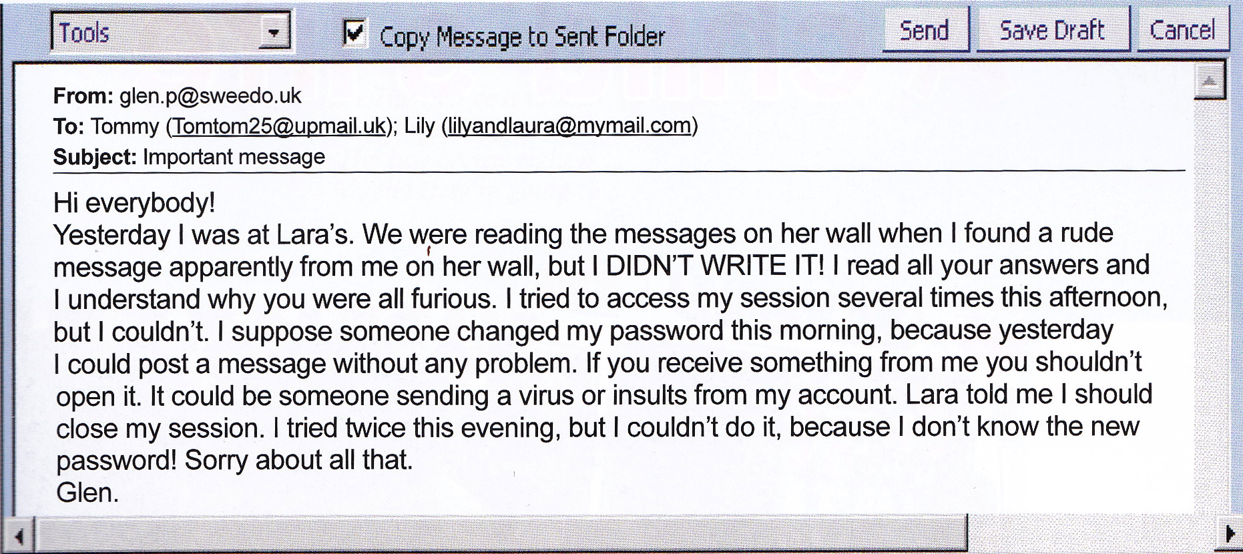

1. What is the nature of the document ?
It is an e-mail.
2. Who is the author of the document ?
It’s Glen.
3. Who is the document addressed to ?
It is addressed to Tommy and Lily.
4 How are Tommy, Glen, Lily and Lara probably connected ?
They are probably friends.
5 Who has a problem ? What is the problem ?
Glen has a problem.Someboday has hacked his account and changed his password.
This person sent Lara a violent, impolite, rude message from his account.
6. Note down 2 things Glen couldn't do ?
Glen couldn’t access his cession and he couldn’t close his cession.
7 What does he advise (conseille) his friends or do or not to do ?
He advises his friends not to open messages from him / to ignore his messages
because they could be hacked too.
8 Is Glen's problem solved ? Why ?
No, his problem is not solved because he doesn’t know the new password.
9 Imagine how Glen feels. Why ?
He is furious, upset because somebody has sent a message from his account.
10 What does this document show / prove ?
The document shows, proves that the internet can be dangerous, is not safe
because of virus, hackers and that the internet can be used improperly / for bad purposes.

Remark : couldn’t + verb = impossibility in the past

should + verb / shouldn’t + verb = advising (conseiller quelque chose à quelqu’un)

Remark : couldn't + verb = impossibility in the past

shouldn't + verb = advising = dire ce que quelqu'un devrait pas faire

should + verb = advising = dire ce quelqu'un devrait faire

Complete with « should » or shouldn't.

1 You have bad results at school. You should work more. You shouldn’t dream in class.
2 You are overweight (90kg). You should eat less. You should do sport. You shouldn’t eat junk food (chocolate, crisps, hamburgers ……).

3 You are always tired. You should go to bed earlier. You shouldn’t watch TV late at night.
4 You don't feel well. You should go to the doctor's.

5 You have difficulties to breathe (respirer). You should stop smoking.

Complete with « should » or shouldn't.

1 You have bad results at school. You ………..….. work more. You ………………… dream in class.
2 You are overweight (90kg). You ………………… eat less. You ………………. do sport. You ……………………….. eat junk food (chocolate, crisps, hamburgers ………………….

3 You are always tired. You …………………. go to bed earlier. You …………………… watch TV late at night.
4 You don't feel well. You ………………….. go to the doctor's.

5 You have difficulties to breathe (respirer). You ……………….stop smoking.

Complete with « should » or shouldn't.

1 You have bad results at school. You ………..….. work more. You ………………… dream in class.
2 You are overweight (90kg). You ………………… eat less. You ………………. do sport. You ……………………….. eat junk food (chocolate, crisps, hamburgers).

3 You are always tired. You …………………. go to bed earlier. You …………………… watch TV late at night.
4 You don't feel well. You ………………….. go to the doctor's.

5 You have difficulties to breathe (respirer). You ……………….stop smoking.

Matching exercise.
Make sentences.

1. Thanks to the computer, we can work quicker | a. because it costs a lot of money.
2. The computer can help to work together | b. too much time playing on their computers.
3.A lot of students use the internet | c. a lot of data.
4. Even if the computer helps to save natural ressources | d. quicker and more easily.
5. As we use less paper and pencils | e. but it can also damage relations between people.
6. A great deal of people use their computers a lot | f. we save natural ressources.
7. Some people use their computers all the time | g. using it for no reasons is a waste of electricity and energy.
8. Not everybody can have a computer | h. consequently a lot of shops close.
9. Thanks to the computer, we can store | i. consequently they get addicted.
10. Thanks to the computer we can find information and have answers | j. but it can be dangerous because of hackers for example.
11. The internet is a good invention | k. because the computer and the internet can be dangerous if the children use it improperly.
12. People spend too much time on their computers | l. which is bad for their eyes.
13. Because of the computer, some jobs disappear | m. to make their life easier.
14. Parental control is necessary | n. so it saves time.
15. A lot of children spend | o. indeed they can't help surfing the net when they have time for example for no reason.
16. Because of the internet, a great deal of people buy on line | p. so some people lose their jobs and are in difficulties.

Let's practise !

Complete the sentences with vocabulary from the sequence.

1 Thanks to the computer, we can __________ a lot of data.

2 As we use less paper and pencils, thanks to the computer we __________ __________ __________ .

3 People __________ too much time on their computers which is bad for their __________.

4 Thanks to the computer and the mobile phone people can easily keep in touch with the others but they can also _______________ the social life because they go out less to meet their friends and families.

5 Some people use their computers or their mobile phones all the time consequently they _____________________________ .

6 Thanks to the computer, we can find information and have answers __________ and
__________ __________ .

7 ______________________________ is necessary because the computer and the internet can be dangerous for the children if they use it improperly.

8 Not everybody can have a computer because it is very ____________ .

9 Because of the computer, some jobs disappear so some people __________ their __________ and are in difficulties.

10 Even if the computer helps to save natural ressouces, using it for no reasons is a __________ of __________ and energy.

11 A lot of children __________ too much time playing on their computers, on their consoles or their mobile phones.

12 The internet is a good invention but it can be dangerous because of hackers for example.

13 Thanks to the computer, we can work __________ so it saves time.

Vocabulary help :

parental control more easily hackers natural ressources online
expensive spend lose too much time waste faster damage / deteriorate
save store eyes sight jobs get addicted time

Vocabulary help :

parental control more easily hackers natural ressources online
expensive spend lose too much time waste faster damage / deteriorate
save store eyes sight jobs get addicted time

Vocabulary help :

parental control more easily hackers natural ressources online
expensive spend lose too much time waste faster damage / deteriorate
save store eyes sight jobs get addicted time

Vocabulary help :

parental control more easily hackers natural ressources online
expensive spend lose too much time waste faster damage / deteriorate
save store eyes sight jobs get addicted time

Complete the sentences with a link word. (no repetitions, please!)

1 The computer is a good invention ……………….. we can work faster and more easily.

2 Children spend a lot of time on their computers ……………….. they should go outside and play with their friends.

3 ……………….. a lot of people use the computer for no reasons, it wastes a great deal of energy.

4 ……………….. the computer is very useful, it is not indispensable for most people.

5 More and more people buy on line ……………….. a lot of shops close.

6 The internet can be dangerous for children ……………….. parental control is necessary.

Complete the sentences with a link word. (no repetitions, please!)

1 The computer is a good invention ……………….. we can work faster and more easily.

2 Children spend a lot of time on their computers ……………….. they should go outside and play with their friends.

3 ……………….. a lot of people use the computer for no reasons, it wastes a great deal of energy.

4 ……………….. the computer is very useful, it is not indispensable for most people.

5 More and more people buy on line ……………….. a lot of shops close.

6 The internet can be dangerous for children ……………….. parental control is necessary.

