Tuesday, March 5th.

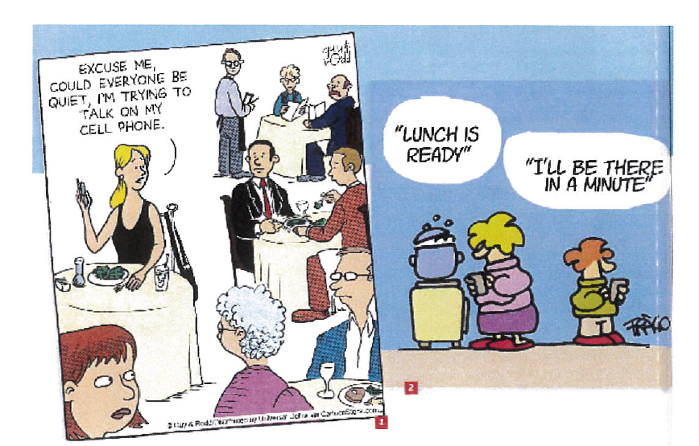
Picture 1 :
We can see some people at the restaurant. They are eating and
they are looking at a woman who is asking them to be quiet
because she is trying to talk on her cell phone.
The other people look surprised and maybe shoked.
The woman is bad-mannered and not respectful of the others.
The message of the artist is that people shouldn't disturb
the others with their phones in public places.
The artist denounces the bad manners of some people and
the fact that people use their phones
too much (anywhere, anytime …..) / the abusive use of
the cell phone.

Picture 2 :
We can see a mother with her son. They are both in the kitchen.
The mother is preparing lunch and she is sending her son a message
to say lunch is ready and the son is answering his mother's
message to say he will be there in a minute.
The problem is that although they are in the same room,
the mother and her son communicate by phone.
The message of the artist is that people are too much
on their phones, use their phones too much
for everyday situations. The artist denounces the fact
that people don't communicate because of their cell phones.

Children don't understand the real meaning of playing outside,
they understand playing video games and not playing football, basketball
with friends for example.
Nowadays, children play too much video games. They spend too much time
on their consoles.

Nowadays, people are too much on their phones. It is dangerous for example
if they walk and text on their mobiles at the same time in street actually
they can provoke accidents.

People are chained to their computers, they can't break free.
Actually people are / get addicted to their computers, they can't help
texting or surfing the net all the time .

Be / get addicted to …..

can't help + Ving

The problem is that old people don't understand new technologies in general
because they don't have the appropriate vocabulary so using a computer for an old
person is difficult.

The message of the author is that the people spend too much time on their computers
or on their phones surfing on the net.

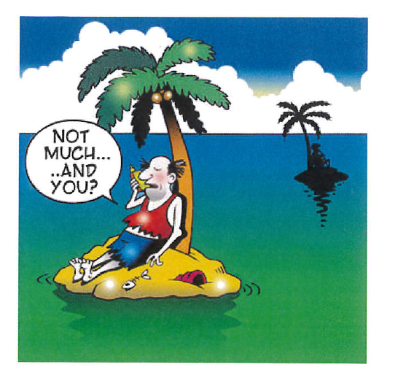
The message of the author is that the phone can be usefull in different situations
to keep in touch with other people whereever you are.
Some people use their phones even if they don't have much to say.

Vocabulary check point.

Nowadays
old people
cell phone
bad-mannered
the fact that
afraid / scared / terrified /frightened
be / get addicted to
can't help + Ving
surf the net
consoles
communicate
break free from
spend time +Ving

can't help + Ving

Adavantages | disadvantages
useful to keep in touch with other people anytime, anywhere  many applications | Difficulties for old people  dangerous / can provoke accidents  people get addicted  too much time on the phone / on the net  use their phone even if they don't have much to say  children play too much videogames  children don't play outside  no direct communication between people  people are not always respectful of the others when they use their mobiles

Read the text and answer the questions.

1. What is the nature of the document ?
It is a mail
2. Who is the author of the document ?
The author is Glen.
3. Who is the document addressed to ?
The document is addressed to Tommy and Lily.
4 How are Tommy, Glen, Lily and Lara probably connected ?
They are problably friends.
5 Who has a problem ? What is the problem ?
Glen has a problem, someone has changed his password
and has sent rude (impolite) messages from his account.
This person has hacked his account.
6. Note down 2 things Glen couldn't do ?
Glen couldn't access to his session and he couldn't close it.
7 What does he advise (conseille) his friends to do or not to do ?
He advises his friends not to open the messages from his account.
8 Is Glen's problem solved ? Why ?
No, because he doesn't know the new password.
9 Imagine how Glen feels. Why ?
Glen is anxious, worried because the hacker can send unpleasant messages.
He is terrified at the idea that somebody can send messages from his account
and that the people who receive the messages believe they are from him.
10 What does this document show / prove ?
The document shows that the internet can be dangerous, anyone who has
your password can enter your session, we mustn't believe all that is written
because the internet is not always safe.

Conseiller à quelqu'un de faire quelque chose ou pas
advise a person to + vb
advise a person not to + vb

Dire ce que quelqu'un devrait faire ou pas

should + verb
shouldn't + verb

People should
People shouldn't

Children should
Children shouldn't

Save nature / natural ressources  easier to make researches  saves time / work faster  business can sell far  store a lot of data  creat and test new products  work more easily  call people far away  find information more easily  some problems can be solved faster (solve a problem)  old people can do shopping online if they can’t go out  buy books online | Destroy social life  bad for the eyes / damage the eyesight  student don’t write and make researches on the internet only  use / waste a lot of electricity/time  expensive / no everybody can buy a computer because of the price  a lot of book stores have closed  supermarkets are affected because of shopping online  a lot of people have lost their jobs

Vocabulary :
quicker
save time
damage relations between people
make life easier / facilitate
natural ressources
a waste of energy
as
it costs a lot of money = it is expensive
store data
disappear
thanks to
because of

Complete the sentences with a link word. (no repetitions, please!)

1 The computer is a good invention ……………….. we can work faster and more easily.

2 Children spend a lot of time on their computers ……………….. they should go outside and play with their friends.

3 ……………….. a lot of people use the computer for no reasons, it wastes a great deal of energy.

4 ……………….. the computer is very useful, it is not indispensable for most people.

5 More and more people buy on line ……………….. a lot of shops close.

6 The internet can be dangerous for children ……………….. parental control is necessary.

Matching exercise.
Make sentences.

1. Thanks to the computer, we can work quicker | a. because it costs a lot of money.
2. The computer can help to work together | b. too much time playing on their computers.
3.A lot of students use the internet | c. a lot of data.
4. Even if the computer helps to save natural ressources | d. quicker and more easily.
5. As we use less paper and pencils | e. but it can also damage relations between people.
6. A great deal of people use their computers a lot | f. we save natural ressources.
7. Some people use their computers all the time | g. using it for no reasons is a waste of electricity and energy.
8. Not everybody can have a computer | h. consequently a lot of shops close.
9. Thanks to the computer, we can store | i. consequently they get addicted.
10. Thanks to the computer we can find information and have answers | j. but it can be dangerous because of hackers for example.
11. The internet is a good invention | k. because the computer and the internet can be dangerous if the children use it improperly.
12. People spend too much time on their computers | l. which is bad for their eyes.
13. Because of the computer, some jobs disappear | m. to make their life easier.
14. Parental control is necessary | n. so it saves time.
15. A lot of children spend | o. indeed they can't help surfing the net when they have time for example for no reason.
16. Because of the internet, a great deal of people buy on line | p. so some people lose their jobs and are difficulties.

Let's practise !

Complete the sentences with vocabulary from the sequence.

1 Thanks to the computer, we can store a lot of data.

2 As we use less paper and pencils, thanks to the computer we save natural ressources .

3 People spend too much time on their computers which is bad for
their eyes.

4 A lot of students use the internet to facilitate their lives.

5 Some people use their computers all the time consequently they get addicted .

6 Thanks to the computer, we can find information and have answers quicker and
easily .

7 Parental control is necessary because the computer and the internet can be dangerous for their children if they use it improperly.

8 The computer can help people to work together but it can also damage relations between people.

9 Not everybody can have a computer because it costs a lot of money.

10 Because of the computer, some jobs disappear so some people get out of work and are in difficulties.

11 A great deal of people use their computers a lot indeed they can’t help surfing the net when they have time for example for no reason.

12 Even if the computer helps to save natural ressouces, using it for no reasons is a __________ of __________ and energy.

13 A lot of children spend too much time playing on their computers.

14 The internet is a good invention but it can be dangerous because of hackers for example.

15 Thanks to the computer, we can work quickly / quicker so it saves time.

16 Because of the internet, a great deal of people __________ __________ __________

