Choose one illustration, describe it and comment.

- Who can you see ?
- Where are they ? / What are they doing ?
- What is the problem ?
- What is the message of the author ?
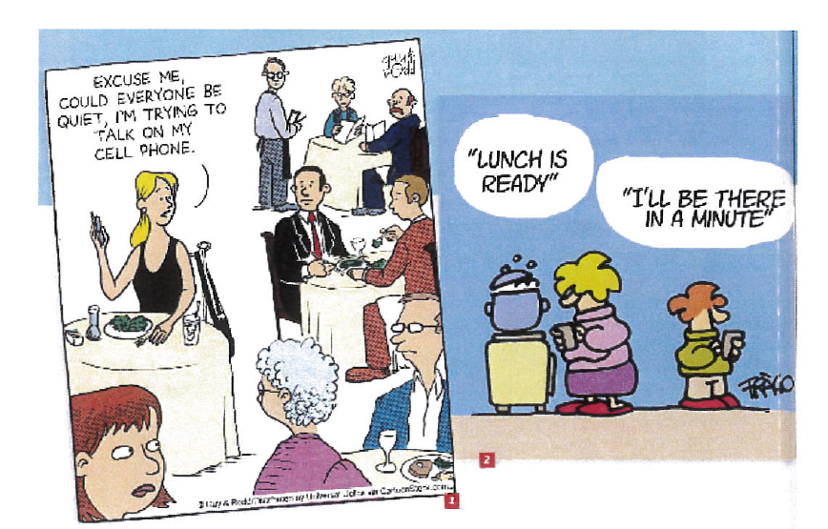
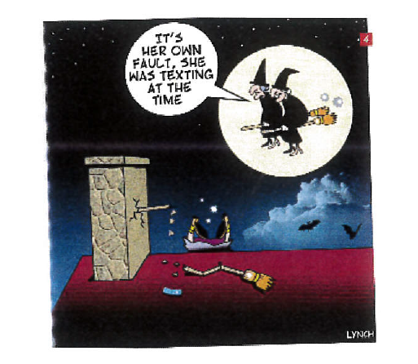
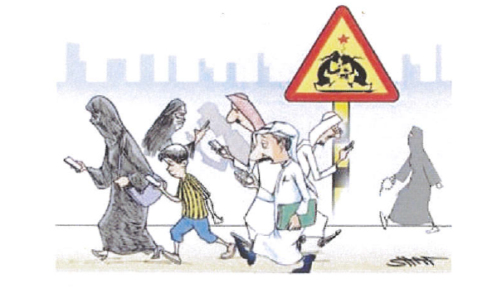
The message of the author is people use their phones anytime,anywhere
It's dangerous actually they can hurt each others and they can have an accident
if they use their phones in the street.

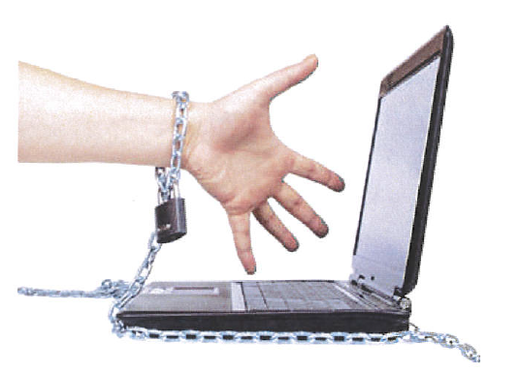
The message of the author is the people can't stop being on their computers /
using their computers actually people are like prisonners or slaves,
they can't break free from their computers.

People can't help using their computers.

Can't help + Ving
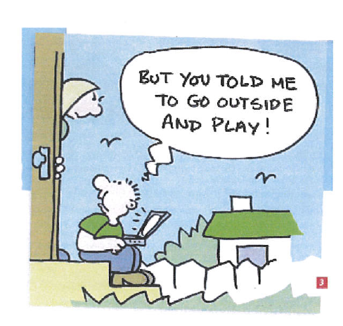

Children don't understand the real meaning of playing outside,
they understand playing video games and not playing football, basketball
with friends for example.
Nowadays, children play too much video games. They spend too much time
on their consoles.

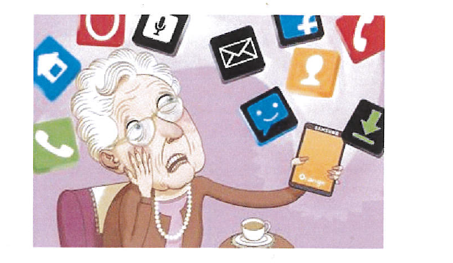
Old people are often lost and afraid with
the new technologies actually they don't understand
because it is too difficult and there are too many applications .

Be afraid = scared = terrified= frightened

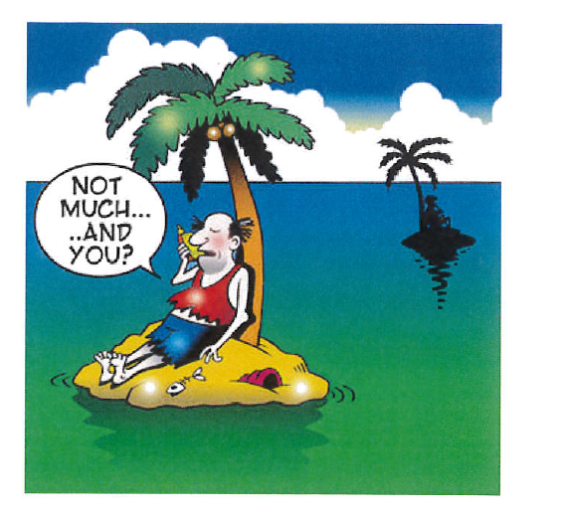

The phone has disadvantages but also advantages because whereever
you are you can communicate with other people / you can keep in touch
with other people.

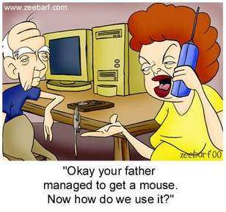
The author's message is that old people have problems with the specific
vocabulary consequently they have difficulties to use the new technologies.

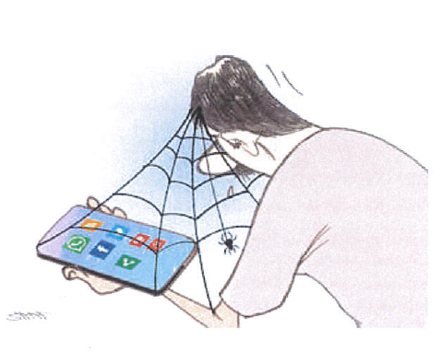

The message of the author is that people stay all the time on their phones
consequently we can imagine that they stay at home a lot.

People spend too much time on their phones.
People spend a lot of time surfing the net, texting or sending messages.

Spend time + ving

