Name : / 10

Conjugate « BE » in the present

Conjugate « HAVE » in the present

Conjugate « LIKE » in the present (affirmative + negative form)
Affirmative form Negative form

Write the list of possessives

mon ma mes

ton ta tes

son sa ses (à lui)

son sa ses (à elle)

notre nos

votre vos

leur leurs

Basic vocabulary.

avec : mais :

parce que : le la les :

un une :

Complete what Prince William is saying with :
- verbs
- possessives
- personal pronouns
- tools words (mots outils).

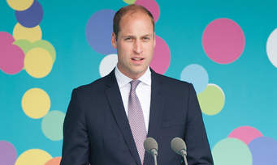

My name is Prince William. I am 37 years old. My wife

is Kate Middleton. We live in London we have / with our

3 children.

I have / We have 2 sons, their names are George and Louis and

1 daughter, her name is Charlotte. George is 6 years old, Charlotte

is 4 and Louis is 1.

George likes football, animals and watching films. His favourite film is « The King

Lion ». He likes chips but he doesn’t like vegetables

(les légumes). Charlotte likes eating. Her favourite food is spicy food (la nourriture

épicée). Charlotte has a passion in common with her great grandmother the queen,

this is / she likes / they like horses. I love my children, they are

fantastic !

Name :

Complete the sentences with :

my his her is am are have has live lives like likes don't like doesn't like I he

she and but

1) Betty is American, she lives in New York. Her father is

a doctor but / and her mother is a teacher. Her parents are super.

2) Bob is 12 years old. He has 1 brother but no sisters.
He likes football but he doesn’t like rugby because it is a
violent sport. His parents are journalists.

Name :

Complete the sentences with :

my his her is am are have has live lives like likes don't like doesn't like I he

she and but

1) Betty …............ American, …............ …............ in New York. …............ father …............

a doctor …............ …............ mother …............ a teacher. …............ parents …............ super.

2) Bob …............ 12 years old. …............ …............ 1 brother …............ no sisters.
…............ …............ football …............ …............ …............ rugby because it …............ a
violent sport. …............ parents …............ journalists.

