Let's go on holidays !

What are your plans for the holidays ? Are you going anywhere or are you staying at home ?
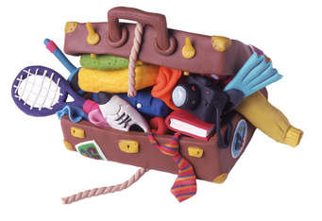


my luggage Where ?

When ?

My summer holidays Type of
accomodation

Who with ? Activities


How long ?

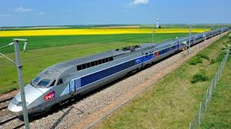

Vocabulary help :

seaside mountain countryside

family grandparents friends uncle aunt

hotel camping site cottage bed and breakfast ( guest house) motorhome caravan tent

swim go fishing go jogging fly my kite build sand castles collect seashells sunbathe read
take photos have naps have long walks have picnic relax visit go sailing lie in the sun
go hiking go horse riding get up late play music play videogames spend time with my friends
go to my grandparents' play badbington play beach volley

books mobile phone console board games sunglasses camera mp3 comics kite rollers


