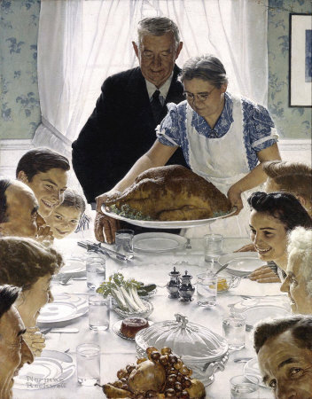
Freedom From Want by Norman Rockwell, published in the Saturday Evening Post in March 1943
Norman Rockwell (1894-1978) was an American painter and illustrator.
He is famous for his illustrations of everyday life.

Freedom From Want by Norman Rockwell, published in the Saturday Evening Post in March 1943
Norman Rockwell (1894-1978) was an American painter and illustrator.
He is famous for his illustrations of everyday life.
- Nature of the document :
The document is □ a photograph □ a drawing □ a poster □ a cartoon
□ an ad/advertisement (for publicity) □ a painting
- Style of the painting :
The painting is □ abstract □ realistic
- The author of the document / The artist who made this piece of art :
The artist who made this piece of Art is ………………………………..
- The title of this piece of art :
This piece of art is entitled ………………………………………..
It was published in ……………………………….
- What does this piece of art represent ?
This piece of art represents ……………………………………………..
Description (voc : I can see – there is /are – in the middle/center – around – in the corner – at the top- people look)
_____________________________________________________________________________________
_____________________________________________________________________________________
_____________________________________________________________________________________
_____________________________________________________________________________________
_____________________________________________________________________________________
_____________________________________________________________________________________

Look at the illustration and write a commentary.
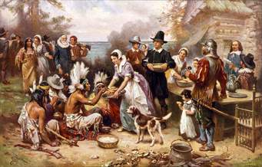

The First Thanksgiving Jean Leon Gerome Ferris (published in 1932)
Jean Leon Gerome Ferris : American painter ( scenes of American History)

1 General introduction : 2 Description of the document :
* the nature of the document * what can you see ?
* the title + the author * what are the people doing ?
* the date of publication
* what the document represents
Je suis capable de décrire un document iconographique en utilisant le vocabulaire adapté.
En donnant :  - la nature du document  - le titre  - le nom de l'auteur  - la date de publication  - des informations sur ce qu'il représente en général | 0 1  0 0,5 1  0 0,5 1  0 0,5 1  0 0,5 1
En décrivant :  - ce que je vois  (en précisant où sur le document)  - ce que les personnages sont entrain de faire | 0 1 2 3 4 5 6  0 1 2 3  0 1 2
En disant ce que je comprends à partir du document. | 0 1 2
Mon travail est soigné :  - je fais attention à l'orthographe.  - je fais des paragraphes.  - mon travail est structuré (organisé) | 0 1 2

What are they doing ?
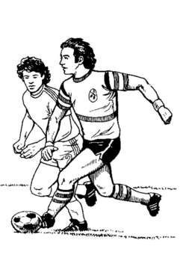
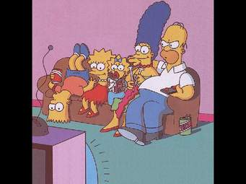

1 2 3



4 5 6
What are they doing ?
1 2 3
4 5 6

