Thanksgiving.

1) Thanksgiving Day.

2) The history of Thanksgiving.

Part 1 Thanksgiving today.

Step 1 : Diaporama. (Who ? Where ? When ?What?)
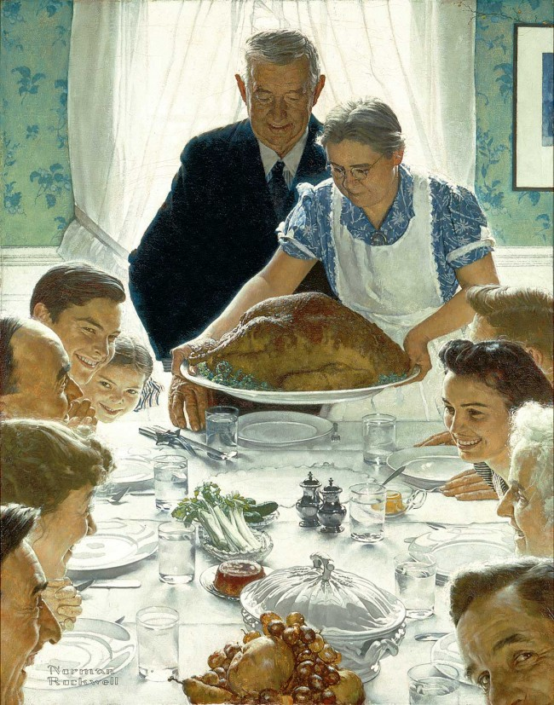
Norman Rockwell (1894-1978), Freedom from Want, 1943. Oil on canvas, 45 3/4″ x 35 1/2″.
Story illustration for The Saturday Evening Post, March 6, 1943.

Norman Rockwell once said, "I paint life as I would like it to be." And no other Rockwell painting better embodies that aspiration than Freedom From Want, one of his most beloved works and the most famous representation of America's quintessential national holiday, Thanksgiving.

Inspired by Roosevelt&#8217;s 1941 address to Congress about four basic human rights, Rockwell created four paintings, starting with Freedom From Want.

Freedom From Want is part of Rockwell's Four Freedoms paintings. He was inspired by President Franklin Roosevelt's January 1941 address to Congress in which he listed four basic and universal human rights — freedom of speech, freedom of worship, freedom from fear and freedom from want. The United States had not yet entered World War II, which was raging in Europe (Japan's attack on Pearl Harbor was in December 1941), and Roosevelt wanted to ignite concern about the real threat of war.

I can see a family. There are the parents, the chidren and the grandparents. They are happy because they are eating together. They are eating turkey. Maybe they are celebrating an important moment but not Christmas because there are no decorations.

Guess what they are celebrating ?
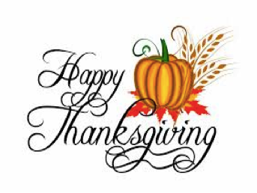
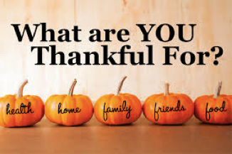
They are celebrating Thanksgiving. People celebrate Thanksgiving to say thank you
for food, home, family friends and health.
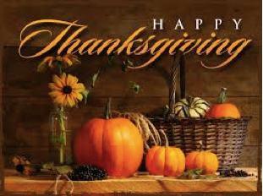

People celebrate Thanksgiving in Fall (Autumn). Thanksgiving is celebrated in America.

Trace écrite :
Thanksgiving is celebrated in America in fall (Autumn). People celebrate Thanksgiving to say thank you for home, family, friends, food and health.

Step 2 : Written comprehension.
Apport de vocabulaire.

Step 3 : Oral comprehension.
Audiolingua Thanksgiving (Angela).

Listen and note down the words you understand.
Compare with your group friends.

From the words write sentences to speak people's habits on Thanksgiving Day.
What do people do in the morning ?
prepare Thanksgiving dinner Watch Macy's parade on TV.
What do people eat ?
turkey vegetables potatoes cranberry sauce gravy pumpin pie eat a lot

What do people do in the afternoon ?
go outside play football watch TV put up the Christmas decorations

What do people do the day after Thanksgiving ?
Black Friday go shopping for Christmas

In the morning, the mother prepares thanksgiving dinner for the family.
She prepares the typical dinner : vegetables, green beans, turkey,
cranberry sauce, potatoes and pumpkin pie. People eat a lot.
People watch Macy's parade on TV.

In the afternoon, people often watch TV, go outside and play football, go shopping,
see friends and prepare the christmas decorations / put up the christmas decorations.

The day after Thanksgiving is Black Friday. On Black Friday people go shopping
to prepare Christmas.

Step 4 : Recap from the illustrations + vocabulary check point.

In groups work from the illustrations to say all you know about Thanksgiving.

- groups 1 + 2 illustrations 1 2 3 4 5 - groups 3 + 4 illustrations 6 7 8 9
- groups 5 + 6 illustrations 10 11 12 13 14 - group 7 illustrations 15 16

Vocabulary check point :
From your work note down the vocabulary you have used.

Fêter : le 4ème jeudi de novembre :
un jour férié : à l'occasion de Thanksgiving :
dire merci pour ….. : être reconnaissant pour … :
se lever tôt : préparer le repas :
un repas spécial : de la dinde :
des légumes : manger beaucoup :
se réunir : rendre visite à des amis :
la saison des achats de noël : le début :
sortir : regarder Macy's parade :
aller faire du shopping : installer les décorations de noël :
Step 5 : Make a mental card.
What words does Thanksgiving evoke to you ? What words does Black Friday evoke to you ?
Thanksgiving Black Friday

Step 6 : Poem.
BE THANKFUL
Be thankful for home
Be thankful for food
Be thankful for birds that fly
Be thankful for sleep
Be thankful for flowers
Be thankful for clouds in the sky.
Be thankful for friends
Be thankful for rain
And the rainbows that follow close by.

Thanksgiving ………………………... on ………………………...of November in the …………....
It is a ………………………………. to say ………………... On this day, people have ……………. ………………… The ……………….. meal is ……………….., ……………….., ……………..,
………………., ……………….., ………………………….. and vegetables.
People watch ……………….. on ………………. or in the ……………….. and they see their ………………. and ………………...
On ……………….. day, people don't ………..…………... and children don't …….……………..

In the morning, the mother prepares thanksgiving dinner for the family.
She prepares the typical dinner : vegetables, green beans, turkey,
cranberry sauce, potatoes and pumpkin pie. People eat a lot.
People watch Macy's parade on TV.

In the afternoon, people often watch TV, go outside and play football, go shopping,
see friends and prepare the christmas decorations / put up the christmas decorations.

The day after Thanksgiving is Black Friday. On Black Friday people go shopping
to prepare Christmas.

Step 7 : Written production test.
From the illustrations write what you know about Thanksgiving ,Thanksgiving Day and Black Friday.

Je suis capable de donner des informations sur : | 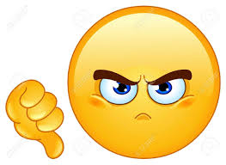  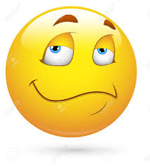    Mark : / 30
Thanksgiving | 0 1 2 3 4
Thanksgiving Day | The meal : 0 1 2 3 4  People's activities : 0 1 2 3 4 5
Black Friday | 0 1 2 3 4
Je suis capable d'indiquer la chronologie | 0 1 2 3
J'utilise du vocabulaire nouveau | 0 1 2 3
Je suis capable de me faire comprendre malgré | de rares erreurs 5 4  des erreurs fréquentes 3 2
Je me fais difficilement comprendre à cause | d'erreurs très fréquentes 0 1
Je soigne mon travail  Je fais attention à l'orthographe | 0 1  0 1
Complete the text and check (vérifie) with your copybooks.
Thanksgiving ………………………... on ……………...…………....of November in the ……....
It is a ………………………………. to say ………………... On this day, people have ……………. ………………… The ……………...….. meal is ..………….., ………..……….., ……………..,
………………., ……………….., ………………………….. and vegetables.
People watch …………...…….. on ………………. or in the ……………….. and they see their ………………. and ………………...

Complete the text and check (vérifie) with your copybooks.

Thanksgiving ………………………... on ……………...…………....of November in the ……....
It is a ………………………………. to say ………………... On this day, people have ……………. ………………… The ……………...….. meal is ..………….., ………..……….., ……………..,
………………., ……………….., ………………………….. and vegetables.
People watch …………...…….. on ………………. or in the ……………….. and they see their ………………. and ………………...

Complete the text and check (vérifie) with your copybooks.

Thanksgiving ………………………... on ……………...…………....of November in the ……....
It is a ………………………………. to say ………………... On this day, people have ……………. ………………… The ……………...….. meal is ..………….., ………..……….., ……………..,
………………., ……………….., ………………………….. and vegetables.
People watch …………...…….. on ………………. or in the ……………….. and they see their ………………. and ………………...

Complete the text and check (vérifie) with your copybooks.

Thanksgiving ………………………... on ……………...…………....of November in the ……....
It is a ………………………………. to say ………………... On this day, people have ……………. ………………… The ……………...….. meal is ..………….., ………..……….., ……………..,
………………., ……………….., ………………………….. and vegetables.
People watch …………...…….. on ………………. or in the ……………….. and they see their ………………. and ………………...

