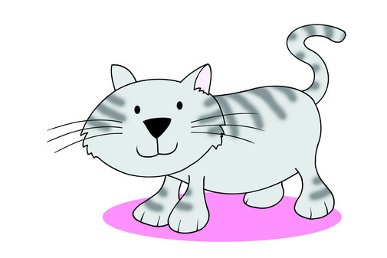

Kitty caught the kitten in the kitchen.

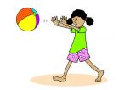

Three free throws.

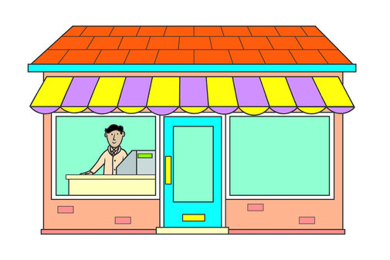

If you want to buy, buy but if you don't want to buy, bye, bye !

