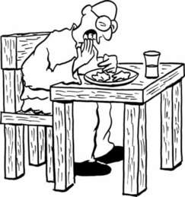
Table manners.
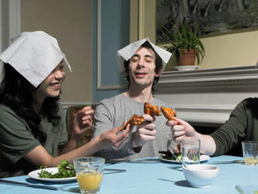
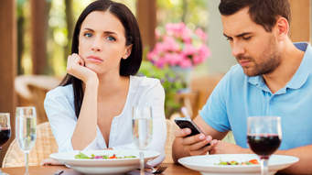

When you are eating there are some good table manners you must respect
and there are some things you mustn't do.

Good table manners  You must | Bad table manners  You mustn't
Eat with cutlery / utensils  eat properly  be calm  sit properly  put your hands on the table | Eat with your fingers  put your elbows on the table  play with food  eat with your mouth open  speak with your mouth full  sing  speak loud  play at the table  put your hands under the table

Let's set the table !

Write the words you know.
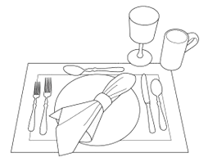
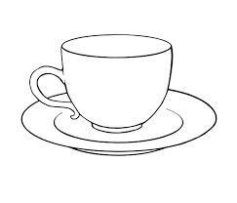

Write the table manners below in the right column.

sit properly / correctly
chew with your mouth closed
put your napkin on your lap
lick your fingers
sip from a coffee spoon or teaspoon
use your mobile phone
use a knife to cut your meat
wait until everybody is served before starting to eat
have your mobile phone on the table
put your elbows on the table
blow on hot food or drink
use a piece of bread on a fork to soak up sauce
ask for permission before you leave the table
play with food
chew with your mouth open
eat properly
speak with your mouth full
speak with your mouth full
finish your pla

Good table manners | Bad table manners

Rules at home when we eat.

When they eat, Maëlle mustn't have her mobile phone on the table.

When they eat, Anatole can have his mobile phone on the table.

When they eat, Marilou can't put her elbows on the table.

When they eat, Lisa is allowed to put her elbows on the table.

When they eat, Justine is not allowed to chew with her mouth open.

Can = is allowed to ( permission / possibility)

Mustn't = is not allowed to (prohibition / impossibility)

Complete with « must / have to», « mustn't / be not allowed / can't», « can / be allowed to ».

When you eat,

you…………………………………. sit properly.
you…………………………………. chew with your mouth closed.
you………………………………….lick your fingers.
you…………………………………. blow on hot food or drink.
you…………………………………. play with food.
you…………………………………. put your napkin on your lap.
you…………………………………. use your mobile phone.
you…………………………………. chew with your mouth open.
you…………………………………. use a knife to cut your meat.
you…………………………………. speak with your mouth.
you…………………………………. wait until everybody is served before eating.
you…………………………………. ask for permission before you leave the table.
you…………………………………. use a piece of bread on a fork to soak up sauce.
you…………………………………. eat with your fingers.
you ………………………………… sip from a teaspoon or a coffee spoon.

Complete with « must / have to», « mustn't / be not allowed / can't», « can / be allowed to ».

When you eat,
you…………………………………. sit properly.
you…………………………………. chew with your mouth closed.
you…………………………………. lick your fingers.
you…………………………………. blow on hot food or drink.
you…………………………………. play with food.
you…………………………………. put your napkin on your lap.
you…………………………………. use your mobile phone.
you…………………………………. chew with your mouth open.
you…………………………………. use a knife to cut your meat.
you…………………………………. speak with your mouth full.
you…………………………………. wait until everybody is served before eating.
you…………………………………. ask for permission before you leave the table.
you…………………………………. use a piece of bread on a fork to soak up sauce.
you…………………………………. eat with your fingers.
you ………………………………… sip from a teaspoon or a coffee spoon.

Complete with « must / have to», « mustn't / be not allowed / can't», « can / be allowed to ».
When you eat,

you…………………………………. sit properly.
you…………………………………. chew with your mouth closed.
you…………………………………. lick your fingers.
you…………………………………. blow on hot food or drink.
you…………………………………. play with food.
you…………………………………. put your napkin on your lap.
you…………………………………. use your mobile phone.
you…………………………………. chew with your mouth open.
you…………………………………. use a knife to cut your meat.
you…………………………………. speak with your mouth full.
you…………………………………. wait until everybody is served before eating.
you…………………………………. ask for permission before you leave the table.
you…………………………………. use a piece of bread on a fork to soak up sauce.
you…………………………………. eat with your fingers.
you ………………………………… sip from a teaspoon or a coffee spoon.

