The right food.
The story of man and woman.

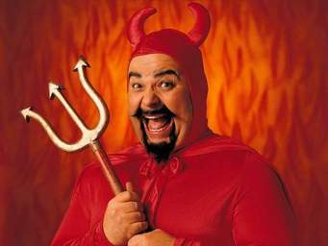
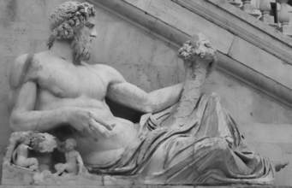

Read and complete the text.

In the beginning, God covered the earth with ………………………………………………..
for Man and Woman to live long and to be ………………...
Then Satan created …………………………... Man and Woman were happy because the food was nice and tasty but they became …………………………...
Then God …………………………………………... the potato, naturally low in fat and ……………………... potassium..
But Satan made ………………………………..with the potato. This food was …………... in……………... and ………………...
Man and Woman became extremely ……………………………..
Then God …………………………………….. beef : not many ……………….. but good for satisfying the appetite.
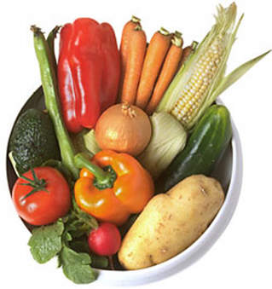
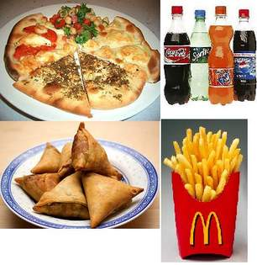
But then ………………………………... created Mc Donald's.

