https://www.youtube.com/watch?v=mzbXaha_8Fc (vegetables)

https://www.youtube.com/watch?v=e4tk2xi85vE (fruits)

Fruit.

Write the names of the fruit you know. Then watch the video and complete or check.
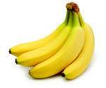
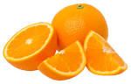
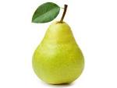
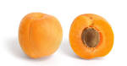
1 _______________ 2 _________________ 3 ______________ 4 ______________

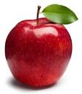
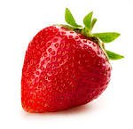
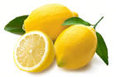
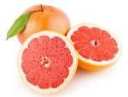
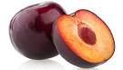
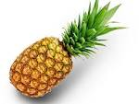
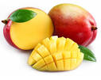
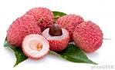
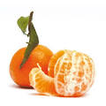
5 ______________ 6 __________________ 7 ________________ 8 ________________
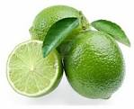
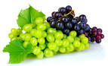
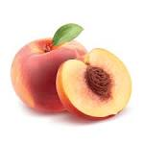
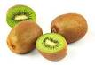
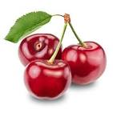
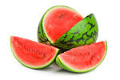
9 ________________ 10 ________________ 11 _______________ 12 _______________ 13 ________________ 14 _______________ 15 _________________ 16 ____________

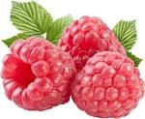
20 ________________ 21 ________________ 23 _______________ 24 ______________

Vegetables.

Write the names of the vegtables you know. Then watch the video and complete or check.


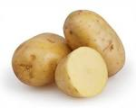
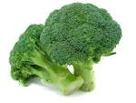
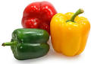
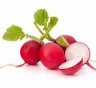
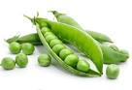
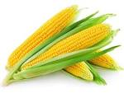
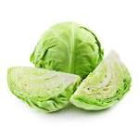
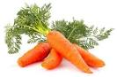
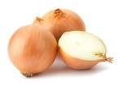
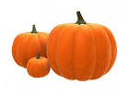
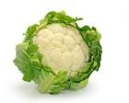
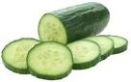
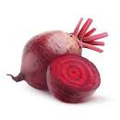
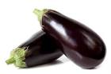
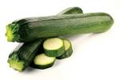
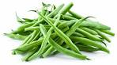
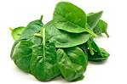
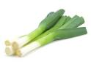
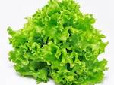
1 _______________ 2 _________________ 3 ______________ 4 ______________
5 _______________ 6 _________________ 7 ______________ 8 ______________
9 ______________ 10 ______________ 11 ______________ 12 ______________
13 ______________ 14 ______________ 15 ______________ 16 ______________
17 ______________ 18 ______________ 19 ______________ 20 ______________

Flash test.

Name :
________________ ________________ _______________ ______________
________________ ________________ _______________ ______________

________________ ________________ _______________ ______________

____________ ____________ ___________ ___________

____________ ____________ __________ ____________
What is the English for « viande » ? Give 4 examples.
What is the English for « volaille ? Give 3 examples

Complete the grid. Don't repeat a word from the previous questions ! No repetition !

dairy products (x4)
Proteins (x2)
grains / starchy food (x4)
drinks | cold drinks (4) hot drinks (2) drinks with alcohol (3)

