I can speak about my last holidays and my Christmas .

My activities during the holidays
(before Christmas / between Christmas and New Year's Day / after New Year's Day)

My last Christmas
(where / who with / my presents)

My impressions about my last holidays and Christmas

I can speak about my last holidays and my Christmas .

My activities during the holidays
(before Christmas / between Christmas and New Year's Day / after New Year's Day)

My last Christmas
(where / who with / my presents)

My impressions about my last holidays and Christmas

I can speak about my last holidays and my Christmas .

My activities during the holidays
(before Christmas / between Christmas and New Year's Day / after New Year's Day)

My last Christmas
(where / who with / my presents)

My impressions about my last holidays and Christmas

I can speak about my last holidays and my Christmas .

My activities during the holidays
(before Christmas / between Christmas and New Year's Day / after New Year's Day)

My last Christmas
(where / who with / my presents)

My impressions about my last holidays and Christmas

Complete the grid with the equivalents of the verbs in the past.
What can you notice ?

Verbs in the base form | Verbs in the past
go
relax
do
watch
play
listen

Complete the grid with the equivalents of the verbs in the past.
What can you notice ?

Verbs in the base form | Verbs in the past
go
relax
do
watch
play
listen

Complete the grid with the equivalents of the verbs in the past.
What can you notice ?

Verbs in the base form | Verbs in the past
go
relax
do
watch
play
listen

Write sentences from the information in the grid.

 | Betty | Patrick and his brother
football |  | V
homework | V | V
swimming-pool | V

Write sentences from the information in the grid.

 | Betty | Patrick and his brother
football |  | V
homework | V | V
swimming-pool | V

Write sentences from the information in the grid.

 | Betty | Patrick and his brother
football |  | V
homework | V | V
swimming-pool | V

Write sentences from the information in the grid.

 | Betty | Patrick and his brother
football |  | V
homework | V | V
swimming-pool | V





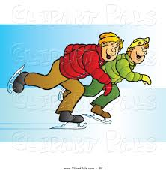
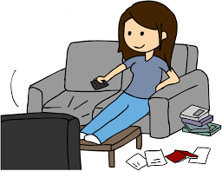
Write about the Christmas holidays from the illustrations.

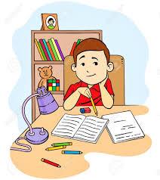
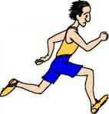

Patrick James Bob Tom and his brother


Becky Alison Kate Jerry

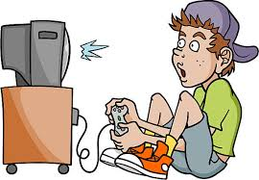
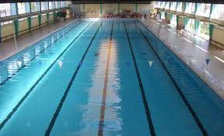

Sandra Jack Jenny Harry

Write about the Christmas holidays from the illustrations.

Patrick James Bob Tom and his brother

Becky Alison Kate Jerry

Sandra Jack Jenny Harry

Name :
/ 20
1) Re-write the sentences in the past.
1 Peter often draws in his freetime.
________________________________________________________________________________
2 Kerry never drinks alcohol.
________________________________________________________________________________
3 David sometimes comes to his grandparents' during the holidays.
________________________________________________________________________________
4 Kate sometimes works on Sundays.
________________________________________________________________________________
5 Rebecca sometimes sleeps at her grandparents' during the holidays.
________________________________________________________________________________
6 Children often bring cakes at school for their birthdays.
________________________________________________________________________________
7 James always cleans his bedroom on Saturday afternoons.
________________________________________________________________________________

2) Complete the sentences with a verb in the past.

1 Kerry …................. Christmas carols (chants de noël) with her cousins on Christmas Day.

2 Sandra …................. her sister a bracelet for Christmas.

3 Andrew …................. at the restaurant with his family on Christmas Day.

4 Ted …................. shopping last week-end. He …................. a denim jacket and a pair of trainers.

5 David and his brother …................. very happy because they …................. a computer for Christmas.

6 Harry …................. his homework during the holidays.

7 On New Year's Day, Philip …................. late because he …................. very tired.

8 Sandy …................. a cake for Christmas dinner.

9 Peter …................. late in the morning during the holidays.

10 Kate …................. a very funny film at the cinema with her friends during the holidays.

