I can speak about my last holidays and my Christmas .

My activities during the holidays
(before Christmas / between Christmas and New Year's Day / after New Year's Day)

My last Christmas
(where / who with / my presents)

My impressions about my last holidays and Christmas

Part 1.
Let's talk about your holidays and Christmas !
Diaporama activities

Trace écrite.
During the holidays, …........ went …....

Remark : the verbs are in the past.

Let's recap !
Complete the grid with the equivalents of the verbs in the past.
What can you notice ?

Verbs in the base form | Verbs in the past
go
relax
do
watch
play
listen

In the past some verbs have « ed » and some verbs have a particular form (you will have to learn them).


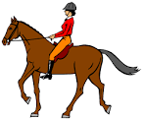

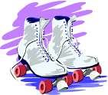
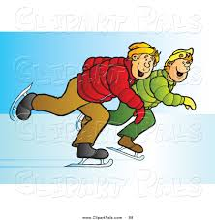
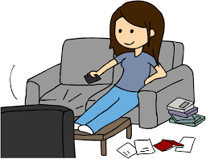
Write about the Christmas holidays from the illustrations.

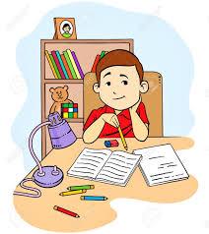
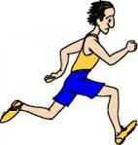

Patrick James Bob Tom and his brother
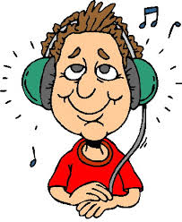

Becky Alison Kate Jerry
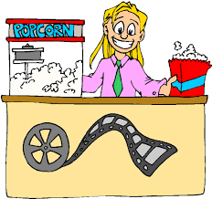
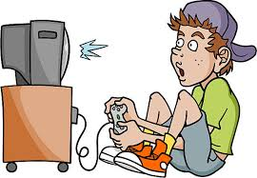
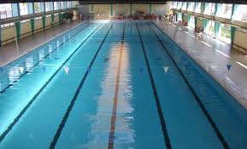

Sandra Jack Jenny Harry

