Animals.

Write the name of the animals below.

peacock duck horse goat calf dog hen pig lama donkey sheep lamb
ox cock goose cow
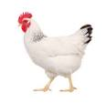
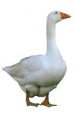
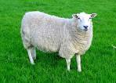

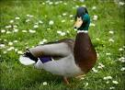

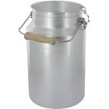
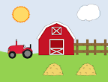
The farm.

What is the name of the farm ?

What is the name of the farmers ?

What animals did you see at the farm ?

How many cows are there ?

How many litters of milk does a cow give in a day approximately ?
A cow gives 20 litters of milk in a day.

What does the farm produce ?
The farm produces milk, apple juice, cider and electricity.

Lunch time !

What did you have for lunch ? ( What did you eat ? What did you drink ?)

Look at the illustrations and note down the vocabulary. (choose from the list).

sweets water chocolate bar sandwich picnic biscuits packed lunch crisps lettuce

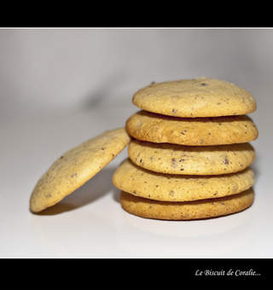
ham tomatoes fruit juice banana cheese salad apple cucumber cake stewed fruit
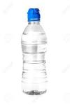
1 2 3 4
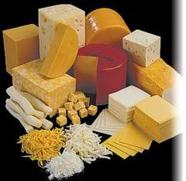
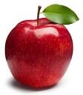
5 6 7 8

9 10 11 12

13 14 15 16

17 18 19

