Charlie and the Chocolate Factory

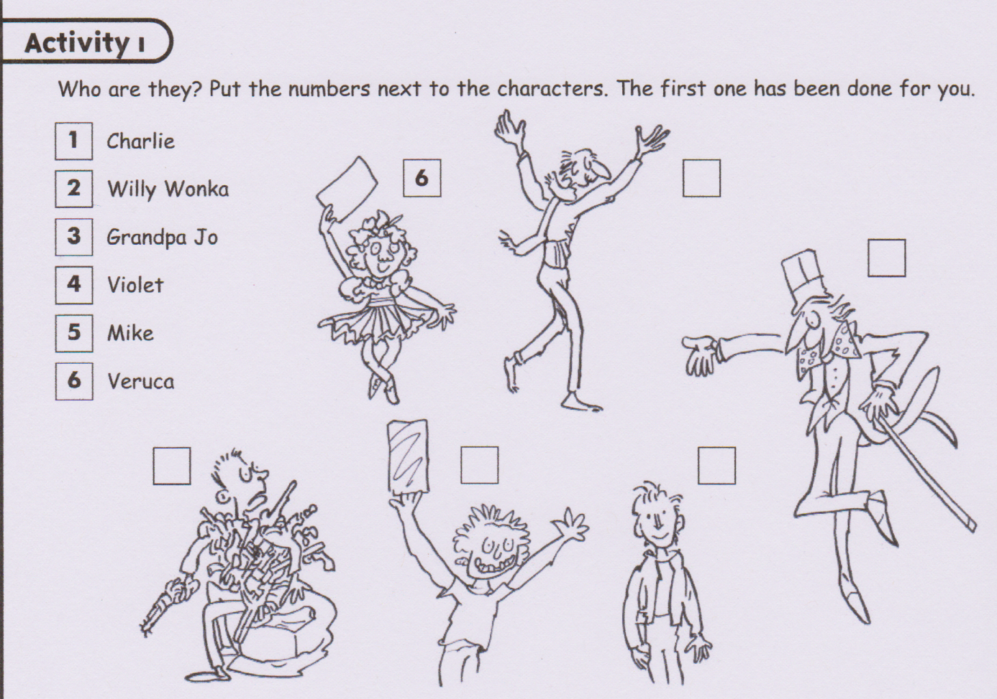
- Who is missing ?..........................................................................
Activity 2
Activity 2
Read the text and find information about the characters.
Names | Physical description | Mental description | Clothes
Here are some adjectives : match them with the appropriate character :
Aggressive, calm, arrogant, annoying, nasty, greedy, spoiled, beastly, proud, bossy, dominant, envious, mean, modest, stupid, rude, selfish, humble, polite, respectful.
Charlie : ………………………………………………………………………………………
Veruca : ……………………………………………………………………………………….
Augustus : ……………………………………………………………………………………
Violet : …………………………………………………………………………………………
Mike : ………………………………………………………………………………………….

Homework
Read the text about Willy Wonka and pick out all the information about his description.
Physical description | Mental description | Clothes

