Activities during the Christmas holidays.
Activity 1.
Write the words which correspond to the illustrations.

presents a party homework a fever ice skating New Year's Eve the housework cards

swimming a stomach ache a yule log a cold turkey a headache late in the morning fish
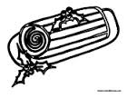
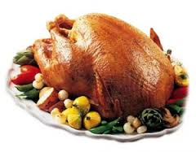
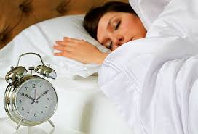
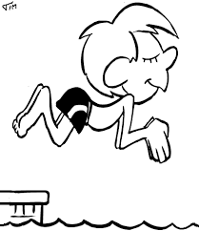

1 2 3 4 5
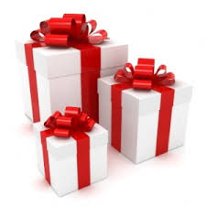
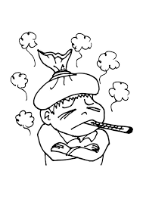
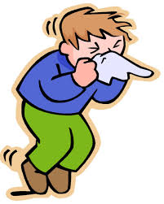
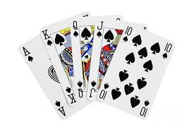
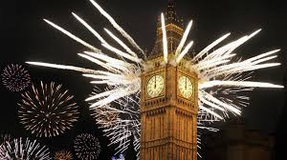
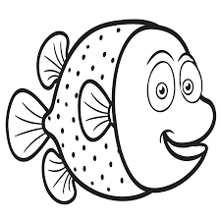
6 7 8 9 10 11
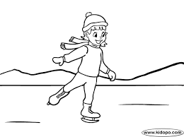
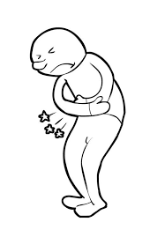
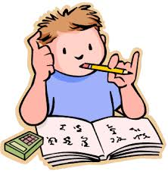
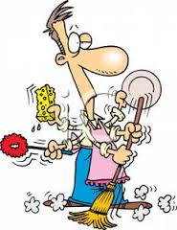
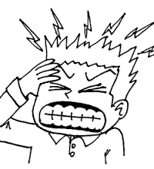
12 13 14 15 16

Activity 2.
Match the verbs in French, in the base form and in the past form.

French | Base form | Past form
Fêter / célébrer  avoir  manger  faire  aller  dormir  jouer  boire  regarder | sleep  do  watch  play  celebrate  drink  have  eat  go | went  watched  drank  celebrated  played  had  slept  did  ate
Activity 3.
Complete the grid with the appropriate verbs in the past.

1. | Xmas at home - Xmas at my grandparents' – Xmas at my uncle's – New Year's Eve at friends'
2. | lots of presents
3. | champagne – fruit juice - coke -
4. | foie gras – smoked salmon – turkey - fish -  a yule log – ice cream
5. | a stomach ache – a headache – a fever – a cold
6. | my homework – the housework
7. | a lot – late in the morning
8. | to my grandparents' – to my friend's - to the cinema - to the swimming-pool - to a party – to the ice-rink - shopping
9. | cards - computer games - video games - football  - with my …... - music
10. | TV

Activity 4.
Express yourselves.
Write about your activities during the Christmas holidays, Christmas and New Year's Eve.
________________________________________________________________________________
________________________________________________________________________________
________________________________________________________________________________
________________________________________________________________________________
________________________________________________________________________________
________________________________________________________________________________
________________________________________________________________________________
________________________________________________________________________________
________________________________________________________________________________
________________________________________________________________________________
________________________________________________________________________________
________________________________________________________________________________
Complete the text about Peter's holidays and Christmas.

During the holidays, Peter went to the swimming pool
with his family and he went to the ice-rink with his friends.
He slept a lot because he loves his bed.
Before Christmas, Peter did his homework and
he did the housework in his bedroom because it was in a mess.

Peter celebrated Christmas at his grandsparents' with his family,
his uncle Greg, his aunt Alice and his cousins Bob and Sandra.
They ate smoked salmon, turkey with vegetables and
as a dessert they ate a yule log. Peter drank coke
but the adults drank champagne and wine.
For Christmas Peter had a guitar by his grandparents,
some books by his uncle and his aunt and a new mobile phone by his parents.

Between Christmas and New Year's Eve, Peter went to the doctor's
because he had a fever and he had a cold.
Peter and his family celebrated New Year's Eve at friends' in London.
On 1st January, he slept late in the morning because he was very tired.
On the week after New Year's Eve, Peter watched TV and he played video games.

Complete the text about Peter's holidays and Christmas.

During the holidays, Peter ……………….. to the swimming pool with his family and
he ……………….. to the ice-rink with his friends. He ……………….. a lot because he loves his bed.
Before Christmas, Peter ……………….. his homework and he ……………….. the housework in his bedroom because it was in a mess.

Peter ……………….. Christmas at his grandsparents' with his family, his uncle Greg, his aunt Alice and his cousins Bob and Sandra. They ……………….. smoked salmon, turkey with vegetables and as a dessert they ……………….. a yule log. Peter ……………….. coke but the adults ……………….. champagne and wine.
For Christmas Peter ……………….. a guitar by his grandparents, some books by his uncle and his aunt and a new mobile phone by his parents.

Between Christmas and New Year's Eve, Peter ……………….. to the doctor's because he ……………….. a fever and he ……………….. a cold.
Peter and his family ……………….. New Year's Eve at friends' in London. On 1st January, he ……………….. late in the morning because he was very tired. On the week after New Year's Eve, Peter ……………….. TV and he ……………….. video games.

