Name :

Write about the people's holidays.
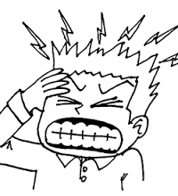
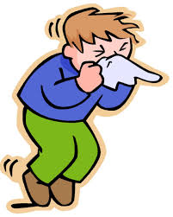
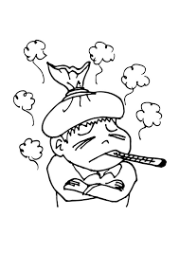




Name :

What is the date today ?
_____________________________________________________________________________

Complete the grid.

French | Base form | Past form
Fêter / Célébrer
Avoir
Manger
Faire
Aller
Dormir
Jouer
Boire
Regarder

Name :

What is the date today ?
_____________________________________________________________________________

Complete the grid.

French | Base form | Past form
Fêter / Célébrer
Avoir
Manger
Faire
Aller
Dormir
Jouer
Boire
Regarder

