Read the sentences and write them in the appropriate column.

You mustn't be aggressive and violent at school.

You mustn't forget your copybook at home.

You must do your homework seriously.

You must be attentive in class.

You must participate in class.

You mustn't make noise in class.

Obligations in class   | Prohibitions in class  

Read the sentences again and complete.

…................ expresses obligation

…................ expresses prohibition.

Write sentences to express obligations and prohibitions in class and at school in general.

Obligations :

In class, you …………………..

Prohibitions :
In class, you …………………..

Flash test.

Name :

Write sentences to express « obligation » or « prohibition ».

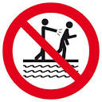
1
____________________________________________________________________
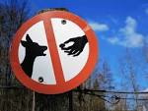
2
____________________________________________________________________


3
____________________________________________________________________
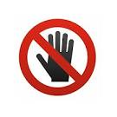
4 i
____________________________________________________________________
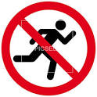
5
____________________________________________________________________

Class rules.

Expressing obligations.

Expressing prohibitions.

Name :

Write a page of the school rules for the English pupils of the school.

In your work you will write about the rules in class.
(5 obligations and 5 prohibitions.)

____________________________________________________________________
____________________________________________________________________
____________________________________________________________________
____________________________________________________________________
____________________________________________________________________
____________________________________________________________________
____________________________________________________________________
____________________________________________________________________

Grille d'évaluation.

Je suis capable de parler des règles de la classe
en exprimant des obligations | 0 1 2
en exprimant des interdictions. | 0 1 2
en utilisant du vocabulaire varié. | 0 1 2 3 4 5 6 7 8 9 10
Mon travail est soigné et organisé. | 0 1

