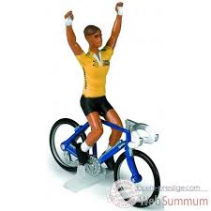

Results of the school cycling competition.
1 Bob
2 Tony
3 Kate
4 Steve
5 Peter
6 Helen
7 Philip
8 Sandra
9 Alison
10 Elizabeth
11 William
12 Charles
13 Dave
14 Mike
15 Joyce
16 Allie
17 Chris
18 Jeff
19 Joe
20 Barbara


