Name :

1) Write the seasons.

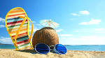
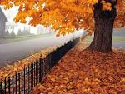
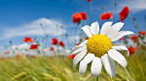


1 Picture 1 is .................................
2 Picture 2 is .................................
3 Picture 3 is .................................
4 Picture 4 is .................................

2)Complete with a season.

1 January is in .................................

2 April is in .................................

3 July is in .................................

4 October is in .................................

5 February is in .................................

6 November is in .................................

3) Answer with a season. (write sentences)

1 When is your birthday ?

2 In which season is August ?

3 In which season is May ?

4 In which season is Christmas ?

5 In which season is Halloween ?

