Evaluation diagnostique 6ème.
Part 1 : Oral comprehension.
Name : Form :
1) Listen and write the numbers you hear.
Part 1 : 0 1 2 3 4 5
Part 2 : 0 1 2 3 4 5
Part 3 : 0 1 2 3 4 5
0 1 2 3 4 5
0 1 2 3 4 5
0 1 2 3 4 5
2) Listen and write the letters you hear.
Part 1 : 0 1 2 3
Part 2 :
Part 3 : 0 1 2
Part 4 : 0 1 2 3
3) Listen and write(in French) the dates you hear.
1. 4.
0 1 2 3
0 1 2 3
0 1 2
0 1 2
2. 5.
3. 6.
0 1 2 3
0 1 2 3
4) Listen and colour.






1 2 3 4 5 6
0 1 2 3
5) Listen and number the illustrations.
0 1 2 3
0 1 2 3
0 1 2 3
6) Listen and number the teacher's questions.
(numérote les questions selon ce que le professeur te demande)
Le professeur te demande :
ton nom si tu as des animaux

ton âge quel est ton sport préféré
ta nationalité si tu aimes aller à la piscine

où tu habites la date de ton anniversaire
si tu as des frères et sœurs le temps qu'il fait
0 1 2 3 4 5 6 7 8 9 10

7) Listen and write information about the girl.
Name + age
Nationality + City
Brothers and sisters ? Names + ages
Pets
Favourite sport + favourite activity at weekends
  At school |   At school
0 1 2 3 4 5 6 7 8 9 10
11 12 13 14 15 16 17 18 19 20
8) Listen and write.
________________________________________________________________________________
________________________________________________________________________________
________________________________________________________________________________
________________________________________________________________________________
Aucun oubli et aucune erreur : 6 | Peu ou pas d'oublis mais de nombreuses erreurs qui ne modifient cependant pas le sens : 3
Aucun oubli et très peu d'erreurs qui ne modifient pas le sens : 5 | Peu ou pas d'oubli mais quelques erreurs qui modifient le sens : 2
Peu d'oublis et peu d'erreurs qui ne modifient pas le sens : 4 | Le texte n'est que partiellement reproduit : 1
Evaluation diagnostique 6ème.
Part 1 : Oral comprehension (teacher's document)
Name : Form :
1) Listen and write the numbers you hear.
Part 1 : 13 8 3 11 18 9 17 5 12 19
Part 2 : 15 14 50 30 60 18 90 16 70 40
Part 3 : 35 77 56 29 73 44 81 54 92 63
0 1 2 3 4 5
0 1 2 3 4 5
0 1 2 3 4 5
2) Listen and write the letters you hear.
Part 1 : D T C P V B
Part 2 : E A I Y
Part 3 : J K H G
Part 4 : F M S N L X
3) Listen and write (in French) the dates you hear.
1. Tuesday, June 10th 4. Wednesday, August 23rd
0 1 2 3
0 1 2 3
0 1 2
0 1 2
2. Friday, April 2nd 5. Monday, January 5th
3. Sunday, September 12th 6. Thursday, July 1st
0 1 2 3
0 1 2 3
4) Listen and colour.
blue
red
yellow
black
orange
1 2 3 4 5 6
0 1 2 3
5) Listen and number the illustrations.
grey
5
2
3
1
6
4
0 1 2 3
0 1 2 3
0 1 2 3
6) Listen and number the teacher's questions.
(numérote les questions selon ce que le professeur te demande)
Le professeur te demande :
ton nom si tu as de animaux
4
10
2
7

ton âge quel est ton sport préféré
ta nationalité si tu aimes aller à la piscine
5
3
9
1

où tu habites la date de ton anniversaire
si tu as des frères et sœurs le temps qu'il fait
8
6
0 1 2 3 4 5 6 7 8 9 10

7) Listen and write information about the girl.

Hi everybody ! I'm happy to meet you. I hope everybody had good holidays. My name's Sandra. I'm 10 years old, I will be 11 in November and I'm American. I live in San Francisco with my family. We are 4 children. I have got 2 brothers , John who is 8 years old and Steve, he is 13 and he loves tennis. I also have 1 baby sister, Betty, she is 1. I love her. She is cute and funny but she often cries. I have 1 cat, his name is Timmy. I am very active, I love sport. I like tennis and swimming but my favourite sport is football. I know it is a bit surprising for a girl. My favourite activity at weekends is going shopping with my friends or with my mother. At school, I like Maths and English but I don't like geography and science. That's all for today. Bye everybody.
0 1 2 3 4 5 6 7 8 9 10
11 12 13 14 15 16 17 18 19 20
8) Listen and write.
Janet is 13 years old and she is English. She lives in London with her mother and her brother but her father is in America. He is a journalist. Her brother is 10. His favourite sport is cricket but he likes tennis. Janet has got 2 dogs, Blacky and Spike.
(proper nouns to write on the board : Janet Backy Spike)

Aucun oubli et aucune erreur : 6 | Peu ou pas d'oublis mais de nombreuses erreurs qui ne modifient cependant pas le sens : 3
Aucun oubli et très peu d'erreurs qui ne modifient pas le sens : 5 | Peu ou pas d'oubli mais quelques erreurs qui modifient le sens : 2
Peu d'oublis et peu d'erreurs qui ne modifient pas le sens : 4 | Le texte n'est que partiellement reproduit 1
Evaluation diagnostique 6ème.
Part 2 : Written production.
Name : Form :
1) Your penpal (correspondant) has sent you a message but your printer (imprimante) doesn't work.
Copy his message.
My family and I aren't English. We are Australians, we live in Sydney. We have a big house on the coast. My mother is a teacher in a primary school and my father is an architect. I am 12 and I am in grade 7 like you.

_______________________________________________________________________________________
_______________________________________________________________________________________
_______________________________________________________________________________________
_______________________________________________________________________________________
_______________________________________________________________________________________
0 1 2 3 4 5 6
2) Restore the spaces, the ponctuation and the capital letters.
1. theboyisinthegarden
________________________________________________________________________________
2. fredlikesrugbyandcricket
________________________________________________________________________________
3. thedogisonthesofa
________________________________________________________________________________
4. kateandbobareatthecinema
________________________________________________________________________________
5 ihavegreeneyesandshortblondhair
_________________________________________________________________________________
0 1 2 3 4 5

3) John's computer has mixed the letters. Write the days correctly as in the examples.
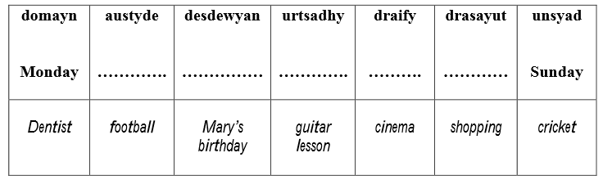
4) Complete the sentences.
0 1 2 3 4 5
Name | My name …..............................................................................................
Age | I …..........................................................................................................
Date of birth | I was born on …...........................................................................................
Place of birth | I was born in …...........................................................................................
Village | I …….. in …...................................
Nationality | I …..........................................................................................................
Brothers and sisters | I ….......................................................................................................
Pets | I ….......................................
 | I …...............................................................................… but I…………… ……………………………………………………………….

0 1 2 3 4 5 6 7 8 9 10

Evaluation diagnostique 6ème.
Part 3 : Written comprehension.

Name : Form :

1) Read the cards and write the number according to the situation.
a) Invitation pour une chasse aux œufs à Pâques : card n° …..
b) Invitation pour un anniversaire : card n° …..
c) Invitation pour Halloween : card n° …..
d) Carte de vœux pour Noël : card n° …..
e) Lettre pour la Saint Valentin : card n° …..

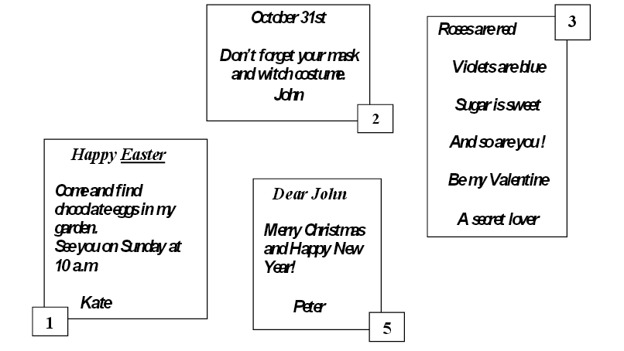
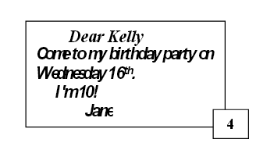
0 1 2 3 4 5

2) This is Bob. Read the text and colour.
Today is the first school day for Bob. He is wearing a red cap on his head, a blue tshirt and a grey jacket.
His trousers are black and his shoes are brown. He has bought a new school bag for the beginning of the year. It is green.

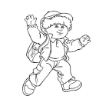
0 1 2 3 4 5

3) What is the weather like ?
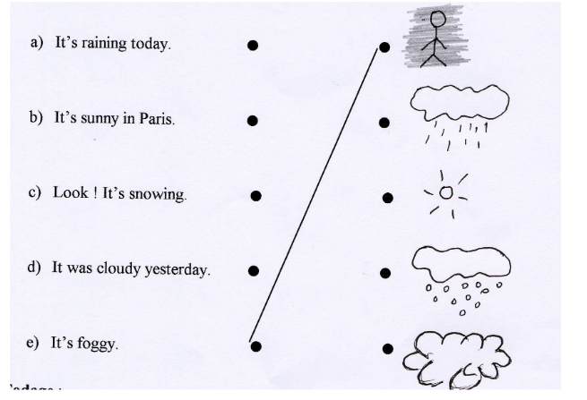
0 1 2 3 4

4) Read the text about Cindy and complete the grid.

Hi ! I'm Cindy, Cindy Parker. I live in Brighton, in the south of England, with my parents and my brother.
I was born on June, 21st 2000. My mum's name is Helen. She is 32. She is a French teacher. My father is 35 and he is a music teacher.
I have a brother, his name is Daniel and he is 14.He loves desserts with chocolate and strawberries. He likes football and going to the park with his friends. I love chocolate too but I don't like strawberries. I prefer apple crumble and lemon cheesecake. They are my favourite desserts. I like listening to music and going to the shops with my mother.
We have 1 dog, his name is Max and 1 rabbit her name is Suzie.

The girl's name
The family's name
The family's place of residence
The girl's age
The number of people in the family
The father's age + his job.
The mother's name + her age + her job
The brother's name + his age
The brother's favourite food
The girl's favourite desserts
The brother's favourite activities
The girl's favourite activities
The family's pets
.
0 1 2 3 4 5 6 7 8 9 10 11 12 13 14 15 16 17 18 19 20
Bilan évaluation diagnostique.
Nom : Classe :

Compréhension orale | Acquis | En cours d'acquisition | Non acquis
Les nombres : 1 à 20
discrimination « ty » « teen »
20 à 90
L'alphabet : B C D P T V
E A I Y
J G
F M S N L X
La date : les jours
les mois
les ordinaux
Les couleurs
Le temps
Questions de base sur soi

Repérer des informations sur une personne
(nom âge nationalité adresse goûts frères et sœurs animaux date d'anniversaire sport et activités préférés)

Compréhension écrite
Comprendre l'idée principale d'un message
Les couleurs
Les vêtements
Le temps qu'il fait
Prélever des informations sur quelqu'un
(nom âge adresse goûts parents frères et sœurs animaux)

Production écrite
Recopier un texte.
Recopier un message et identifier les mots
- en identifiant les mots qui le constituent
- en mettant les majuscules
- en en mettant la ponctuation
Orthographe des jours de la semaine
Se présenter

