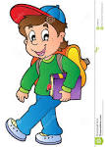
Complete the sentences with the appropriate
My name …..... Bob. I ….... 10 years old.
I ….... Australian. I ….... in Sydney. I …..........
2 brothers and 1 sister. I …....... music.
My favourite kind of music ….... Rap. I …......
sport too. My favourite sport ….... tennis.
My mother ….... slim and medium size.
She ….... a nurse.
My father ….... tall and a little plump.
He ….... a Biology teacher.
verbs.

