Jennifer's house.

Jennifer's bedroom.

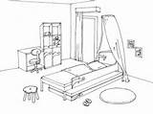

Jennifer and her family's habits

 | Me | My parents | My sister | Family
kitchen |  | breakfast | homework
garden | play with dog |  |  | have lunch (sunny)
living-room | listen to music | watch TV | phone friends
bedroom | homework | watch TV | homework  play with friends
dining-room |  |  |  | lunch at week-ends

