Read the sentences, circle the verbs and write the verbs corresponding to the illustrations.

1 I go to bed at 9.15

2 I have breakfast at 7.15.
3 I take the bus at 8.00.

4 I get dressed after breakfast.

5 I get back home at 5.30.

6 I wake up at 7.00.

7 I do my homework at 17.30.

8 I have dinner with my family at 7.30.

9 I get up at 7.20.

10 I arrive at school at 8.15.

11 I have my shower before dinner.

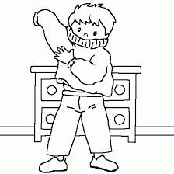
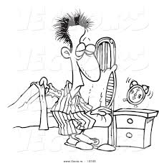

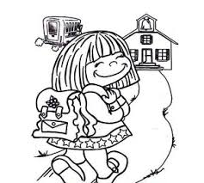

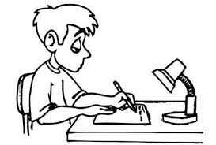

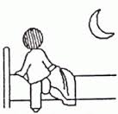
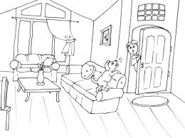

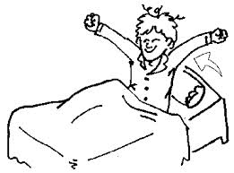

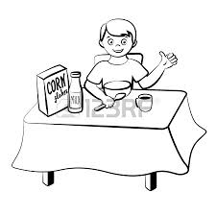
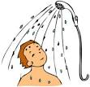

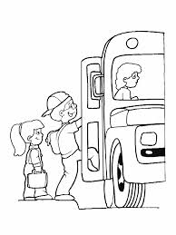

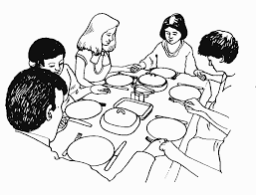

What time do you …............. ?

wake up

get up

have breakfast

get dressed

take the bus

arrive at school

do my homework

have my shower
take my shower

have dinner

go to bed

