Flash test.
Name :
1) What time is it ? Listen and write the times.
:
:
:
:
:
:
:
:
:
:
:
:
:
:

2) Listen and complete the grid with the times you hear.

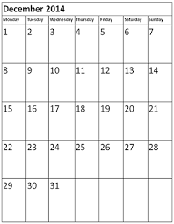
Paul's diary Kate's diary Mrs Andrews's diary
3) Listen and note the opening times.

Madame Tussauds Wax Museum.
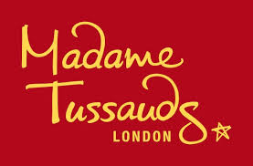
Opening times :

Buckingham Palace

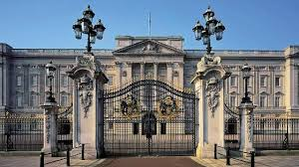
Opening times :

