Name :
Listen and draw the hands on the clocks.
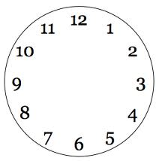

Write the times.

It's quartre past tenteew five

it's tenteew past five

it's quarter pats five

it's half past ten

it's quarter past

it's

it's quarter past

it's five past ten

it's tenty past eignt

