What time is it ?
What is the time ?

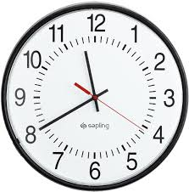
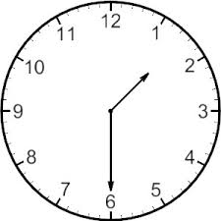
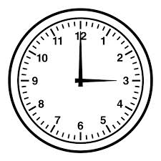
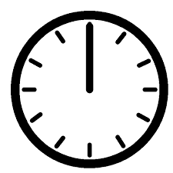
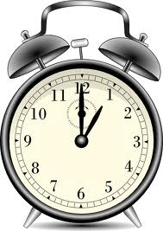

________________________ ___________________ ____________________

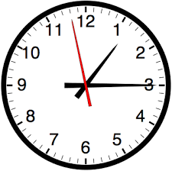
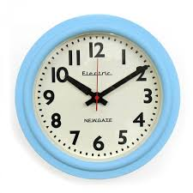

____________________ ____________________ ____________________
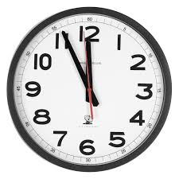
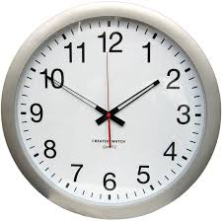

____________________ ____________________ ____________________

What time is it ?
What's the time ?

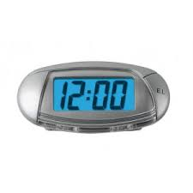
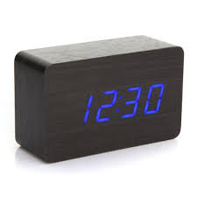
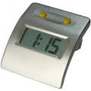
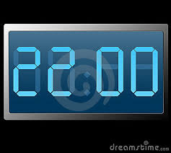
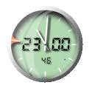
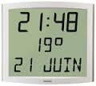

____________________ ____________________ ____________________

____________________ ____________________ ____________________
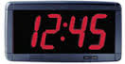
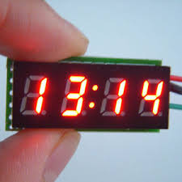
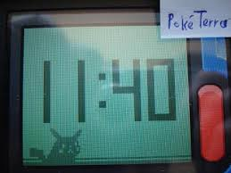

____________________ ____________________ ____________________

Listen and write the times.

:
:
:
:
:
:
:
:
:
:
:
:

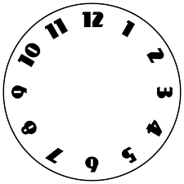

Listen and complete the grid.

 | doctor | dentist | vet | hairdresser
Patrick
Helen
Sandra
Paul

Listen and complete the grid.

 | doctor | dentist | vet | hairdresser
Patrick
Helen
Sandra
Paul

Listen and complete the grid.

 | doctor | dentist | vet | hairdresser
Patrick
Helen
Sandra
Paul

Listen and complete the grid.

 | doctor | dentist | vet | hairdresser
Patrick
Helen
Sandra
Paul

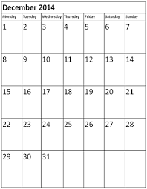

What time is it ?
What is the time ?

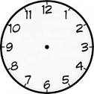
Match the clocks.

03:00

09:30

19:40

16:50

06:10

10:15

14:45

What time is it ?
What is the time ?

Match the clocks and the time.

It's quarter past ten

It's half past four

It's ten past six

It's twenty to nine

It's three oclock

It's quarter to four

It's five to seven

What time is it ?
What's the time ?



