A typical day at school
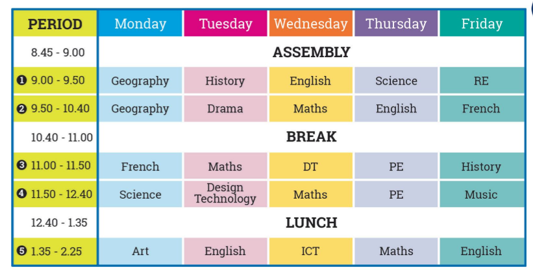
Look at the timetable.
- Underline in blue the school subjects you study in your school.
- Underline in red the school subjects you do not study in your school.
- What are the differences with French timetables ?
………………………………………………………………………………………………………………………………………………………………………………………………………………………………………………………………………………………………………………………………………………………………………………………………………………
Vocabulary :
RE : you discover the history of Christianism, Islam and Judaism :……………………………………….
ICT : you learn about computers :………………………………………………………………….
DT : you design and create objects :……………………………………………………………..

