School things.

Write the words under the corresponding illustrations.

a schoolbag a rubber a pencil a book a pencil sharpener a ruler a pencilcase a copybook a pen a glue stick

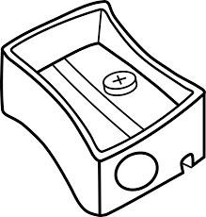
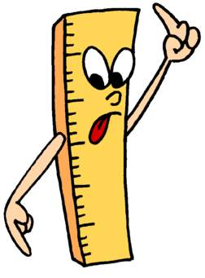

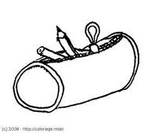
1 _____________

3 _________________

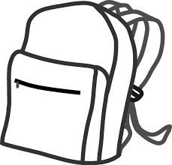
2 ____________________

4 ___________________________

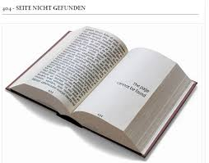

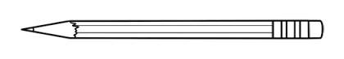
5 ________________________

6 ____________________


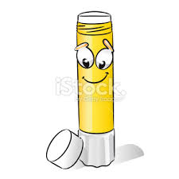

7 ____________________

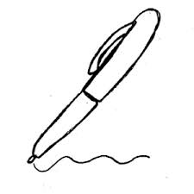
8 ___________________

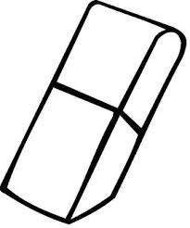

10 _____________________

9 _______________________

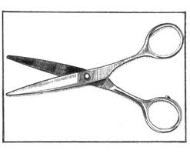
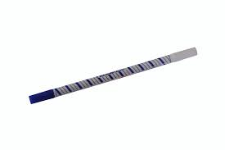
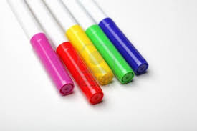
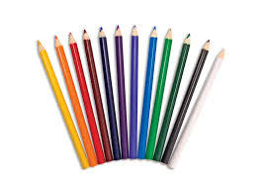
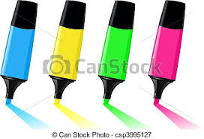
Some more school things.

Write the words under the corresponding illustrations.

some highlighters a tipex a binder a sheet of paper an ink eraser compasses some felt pens a cartridge some colouring pencils (a pair of) scissors
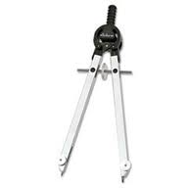
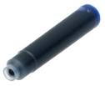

2 _____________

3 _________________
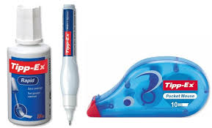
1 ____________________

4 ___________________________
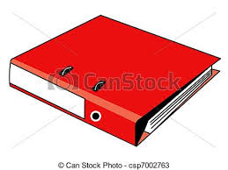

5 ________________________

6 ____________________

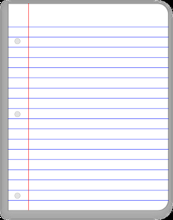
7 ____________________

8 ___________________

10 _____________________
9 _______________________

School things

S | S | G | T | P | X | T | G | H | J | P | K | W | S | H
T | N | H | P | J | E | J | J | N | E | S | C | C | R | I
I | K | E | E | X | H | I | Q | N | Y | A | I | A | O | G
P | Q | P | P | E | U | O | C | B | G | H | T | R | S | H
E | I | O | N | T | T | I | O | V | V | Z | S | T | S | L
X | Y | G | A | B | L | O | O | H | C | S | E | R | I | I
U | L | S | E | C | K | E | F | N | E | P | U | I | C | G
J | M | O | A | A | O | Z | F | P | M | L | L | D | S | H
A | C | S | U | W | B | M | I | H | A | P | G | G | B | T
V | E | K | O | O | B | Y | P | O | C | P | P | E | R | E
P | E | N | C | I | L | S | H | A | R | P | E | N | E | R
I | N | K | E | R | A | S | E | R | S | U | I | R | S | Z
N | X | R | U | B | B | E | R | A | H | S | L | K | D | R
I | H | Q | A | E | P | K | B | H | N | D | E | E | S | C
K | A | M | P | P | O | B | R | E | P | U | C | S | R | I

BOOK | CARTRIDGE | COMPASSES
COPYBOOK | FELTPENS | GLUESTICK
HIGHLIGHTER | INKERASER | PEN
PENCILCASE | PENCILSHARPENER | RUBBER
RULER | SCHOOLBAG | SCISSORS
SHEETOFPAPER | TIPEX

Solution.

S | S | G | T | P | X | T | G | H | J | P | K | W | S | H
T | N | H | P | J | E | J | J | N | E | S | C | C | R | I
I | K | E | E | X | H | I | Q | N | Y | A | I | A | O | G
P | Q | P | P | E | U | O | C | B | G | H | T | R | S | H
E | I | O | N | T | T | I | O | V | V | Z | S | T | S | L
X | Y | G | A | B | L | O | O | H | C | S | E | R | I | I
U | L | S | E | C | K | E | F | N | E | P | U | I | C | G
J | M | O | A | A | O | Z | F | P | M | L | L | D | S | H
A | C | S | U | W | B | M | I | H | A | P | G | G | B | T
V | E | K | O | O | B | Y | P | O | C | P | P | E | R | E
P | E | N | C | I | L | S | H | A | R | P | E | N | E | R
I | N | K | E | R | A | S | E | R | S | U | I | R | S | Z
N | X | R | U | B | B | E | R | A | H | S | L | K | D | R
I | H | Q | A | E | P | K | B | H | N | D | E | E | S | C
K | A | M | P | P | O | B | R | E | P | U | C | S | R | I

Complete with « a », « an » or « some » .
1 a ruler.
2 a pen.
3 an ink eraser.
4 a blue eraser.
5 some colouring pencils.
6 an orange copybook.
7 a copybook.
8 an orange highlighter.
9 a tipex.
10 a pencil sharpener.
11 a rubber.
12 some black cartridges.

Complete with « a » or « an ».
1 an elephant 2 a lion 3 a goose
4 an enormous shark 5 a grey elephant 6 a white goat

Complete with « a », « an » or « some » .
1 …......... ruler.
2 …......... pen.
3 …......... ink eraser.
4 …......... blue eraser.
5 ……… colouring pencils.
6 …......... orange copybook.
7 …......... copybook.
8 …......... orange highlighter.
9 …......... tipex.
10 …......... pencil sharpener.
11 …......... rubber.
12 ………….. black cartridges.

Complete with « a » or « an ».
1 …....... elephant 2 …....... lion 3 …....... goose
4 …....... enormous shark 5 …....... grey elephant 6 …....... white goat

Complete the sentences with school objects.

What is necessary for the English class ?
For the English class, I must always have my copybook.

What is necessary for the French class ?
For the French class, I must always have
mybinder with some sheets of paper and
sometimes my book.

What is necessary for the Maths class ?
For the Maths class, I must always have my 2 copybooks
and sometimes my book.

What is necessary for the History class ?
For the History class, I must always have my copybook
and sometimes my book.

What is necessary for the Biology class ?
For the Biology class, I must always have my binder
with some sheets of paper.

What is necessary for the Music class ?
For the music class, I must always have my binder
with some sheets of paper.

What is necessary for the Technology class ?
For the Technology class, I must always have my binder

In my schoolbag, I must always have my pencil case,
my ruler, my diary, my pad, some sheets of paper,
my felt pens and my colouring pencils.

Today is Monday, 7th November.

In my pencilcase, I must always have my eraser,
my scissors, my compasses, some highlighters,
some pens, my pencil, my pencil sharpener,
a glue stick, a tipex and an ink eraser.

Complete the sentences with school objects.

What is necessary for the English class ?
For the English class, I must have my …...............................

What is necessary for the French class ?
For the French class, I must have my …..................................

What is necessary for the Maths class ?
…...........................................................................................................

What is necessary for the History class ?
…...........................................................................................................

What is necessary for the Biology class ?
…...........................................................................................................

What is necessary for the Music class ?
…...........................................................................................................

What is necessary for the Technology class ?
…...........................................................................................................

Name : Mark : / 15
1) What is the date today ?

Today is ............................................................................................

2) Write the vocabulary. 12 points

______________ __________________ _________________ _______________

____________ ____________ _ ______________ _____________

______________ _______________ ________________ _____________

3) Complete with « a » « an » or « some ». 3 points

1 I have ............... English test today.

2 It is not ............... difficult exercise.

3 Write ............... essay.

4 I often have ............... enormous schoolbag because I have got ............... books in my schoobag.

5 Ask your friend ............... questions.

Name :
4) Answer the questions.

1 What is necessary for the French class ?

________________________________________________________________________________
________________________________________________________________________________
2 What is necessary in your schoolbag ? (4 different things)

In my schoolbag, I ________________________________________________________________
________________________________________________________________________________
________________________________________________________________________________
3 What is necessay in your pencilcase ? (5 different things)

In my pencilcase, I ________________________________________________________________
________________________________________________________________________________
________________________________________________________________________________

Je suis capable de : | Mark : / 20      
dire ce que je dois avoir | 0 1
dire ce que je dois toujours avoir | 0 1
dire ce que je dois avoir parfois | 0 1
Utiliser les déterminants :  a  an  some | 0 1  0 1  0 1
utiliser du vocabulaire adpté | 0 1 2 3 4 5 6
soigner l'orthographe | 0 1 2 3 4
respecter la syntaxe de la phrase. | 0 1 2
produire un travail soigné | 0 1 2

