Five white mice.

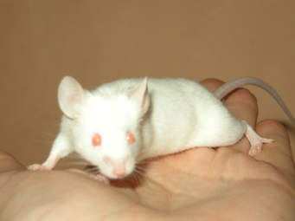
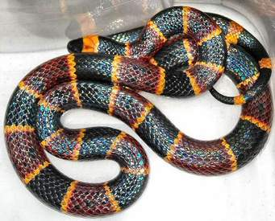
I love cats. Do you?
Do you love cats too?
No, I don't. I really really don't!
Oh... I see... Well...
I like snakes. Do you?
Do you like snakes too?
No, I don't. I really really don't!
Oh... I see... Well...
I hate mice. Do you?
Do you hate mice too?
No, I don't. I really really don't!
Oh you like mice! Do you really?
Yes, I do! I have five!
I like my five white mice!

