Charlie and the chocolate factory.
(Written comprehension)

Read the texts page 28.
1) Pick out the family vocabulary and complete the list with words you know.
Father mother parents grandparents grandpa grandma grandmother grand father aunt uncle cousin nephew niece children / kids son daughter grandson granddaughter
2) Complete Charlie's family tree.
3) Complete the sentences with a member of the family.
1 Charlie is Mr and Mrs Bucket's ….....................
2 Grandpa George is Mr Bucket's …..................
3 Mr and Mrs Bucket are Charlie's …..............
4 Mrs Bucket is Grandpa George and Grandma Georgina's …............
5 Grandma Geargina is Mrs Bucket's …...............
6 Charlie is grandpa Joe and grandma Josephine's …..........
7 Grandpa Joe is Charlie's …...........
8 Grandma Georgina is Charlie's …............
9 Grandpa Joe and grandma Josephine are Charlie's …........
10 Grandpa George and grandma Georgina are Mrs Bucket's …...............

4) Complete with the name of a person.
1 …......................................................... is grandma Georgina's daughter.
2 …......................................................... is Charlie's grandfather.
3 …......................................................... is grandpa Joe's son.
4 …......................................................... are Charlie's parents.
5 …......................................................... are Charlie's grandparents.
6 …......................................................... is Mrs Bucket's mother.
7…......................................................... is grandpa Joe's grandson.

8 …......................................................... is Charlie's grandmother.

9 …......................................................... is Grandma Josephine's husband.

10 …......................................................... is Grandpa George's wife.

The Royal family tree.

Prince Charles

1) Read the text and complete the royal family tree.
Queen Elizabeth has got 4 children, Prince Charles, Princess Anne, Prince Andrew and Prince Edward. Prince Charles first married Lady Diana and they had 2 sons, Prince William and
Prince Harry. Prince Harry married Meghan Markle last year in May on the 19th.
Kate Middleton is Prince William's wife. They have got 1 son, called Prince George. Prince George has got a young sister called Princess Charlotte. Prince Philip is Prince George and
Princess Charlotte's greatgrandfather.

2) Complete the sentences.
1 Prince Edward is Prince William and Prince Harry 's………………..

2 Prince Harry is Prince Charles's ……………...
3 Prince William and Prince Harry are Queen Elizabeth 's ………………..

4 Prince Charles is Princess Charlotte's ………………..

5 Prince Philip is Prince George's ………………..

6 Princess Anne is PrinceCharles and Prince Edward's ………………..

7 Prince Charles is Princess Anne 's ………………..
8 Princess Anne is Queen Elizabeth 's ………………..
3) Write as many sentences as possible.
1 Queen Elizabeth is ….................

2 Prince William is ….......................

3 Kate Middleton is …...........................

4 Prince Edward is ….................................…

4) Follow up work.

Le père de Fred

La femme de Steve

Le frère de kate.

La tante de kerry.

Le neveu de Jerry.

Le fils de Paul et Mary

Le mari d'Alice

La fille de James

Pronounciation « 'S »

Wednesday, March 21st

Remark : le fils du Prince Charles

Prince Charles's son.

La sœur du Prince Edward

Prince Edward's sister

L'oncle du Prince Harry

Prince Harry's uncle

« 'S » = / Z / / S / / IZ /

Kate's brother
/ S /

Steve's daughter
/ Z /

James's son
/ IZ /

Listen and write the number of the sentences in the correct column.
Part 1 :
1 Peter's father 2 Sandra's aunt 3 Kate's brother 4 Patrick's mother 5 Chris's uncle

6 James's cousin 7 Helen's grandmother 8 Charles's son 9 Suzie's grandfather.

10 Henry's nephew
/ S / | / Z / | / IZ /
3 Kate's brother  4 Patrick's mother | 1 Peter's father  2 Sandra's aunt  7 Helen's grandmother  9 Suzie's grandfather.  10 Henry's nephew | 5 Chris's uncle  6 James's cousin  8 Charles's son

Part 2 :

1 Fred's father 2 Jack's wife 3 Joyce's sister 4 Patrick's daughter 5 Elizabeth's husband

6 Philip's niece 7 Charlotte's nephew 8 Fanny's uncle 9 Liz's aunt 10 Steve's son

/ S / | / Z / | / IZ /
2 Jack's wife  4 Patrick's daughter  5 Elizabeth's husband  6 Philip's niece  7 Charlotte's nephew | 1 Fred's father  8 Fanny's uncle  10 Steve's son | 3 Joyce's sister  9 Liz's aunt

Oral comprehension.
Practise 1
1) Listen and write the names you hear.

Philip Patrick Helen Steve Dave Jack Betty Sandra Rebecca Kate Joyce Chris Elizabeth

2) Listen and complete the family tree.

Kate

Helen is Kate's mother.
Kate has got 1 brother,Steve and 1 sister, Sandra.
Steve's wife is Joyce.
Betty is Steve and Joyce's daughter.
Patrick is Sandra's husband.
Philip is Betty's cousin.
Elizabeth is Philip's sister.
Jack is Betty's grandfather.
Rebecca is Betty's sister and Chris's wife.
Dave is Elizabeth's husband.

Practise 2

1) Listen and write the names you hear.

Fred Betty Edward Joyce Paul Chris Sandra Kate Anne James Liz Philip

2) Listen and complete the family tree.

Fred Betty

Peter Helen Paul Joyce

Patrick Sandra Edward Anne

Edward is Joyce's son.
Fred is Edward's grandfather.
Anne is Edward's sister.
Paul is Joyce's husband.
Helen is Edaward and Anne's aunt.
Sandra and Patrick are Edward and Anne's cousins.
Peter is Helen's husband.

Oral comprehension.
Practise 1
1) Listen and write the names you hear.

2) Listen and complete the family tree.

Kate

Practise 2

1) Listen and write the names you hear.

2) Listen and complete the family tree.

Edward

1) Listen and write the names you hear.

2) Listen and complete the family tree.

Edward

1) Listen and write the names you hear.

2) Listen and complete the family tree.

Edward

Oral comprehension test.

Name :
1) Listen and write the number of the sentences in the correct column. / 2,5 pts

1 Suzie's mother 2 Patrick's wife 3 Jack's nephew 4 James's brother 5 Mary's father

6 Joyce's cousin 7 Charlotte's mother 8 Philip's grandson 9 George's uncle

10 Edward's wife
/ S / | / Z / | / IZ /

2) Listen and write the names you hear. / 2,5pts
Fred Charles Edward Paul Jack Charlotte Mary Alison Kate Helen
3) Listen and complete the family tree. / 10 pts

1 Charles is the grandfather.
2 Paul is Charles's son.
3 Jack is Paul's nephew.
4 Fred and Helen are Jack's cousins
5 Alison is Fred and Helen's mother.
6 Mary is Fred's aunt.
7 Edward is Mary's husband.
8 Kate is Jack's sister.
9 Charlotte is Alison's mother in law.
10 George is Suzie's husband.

Oral comprehension test.

Name :

1) Listen and write the number of the sentences in the correct column. / 2,5 pts
/ S / | / Z / | / IZ /

2) Listen and write the names you hear. / 2,5 pts

3) Listen and complete the family tree. / 10 pts

1) Read and complete the family tree.

Harry Kate

Jack Helen Philip Kerry

Peter Janet Andrew Rebecca

Kate's daughter is Helen.
Helen's brother is Philp.
Kerry is Philip's wife.
Peter is Helen's son.
Jack is Helen's husband.
Rebecca is Philip and Kerry's daughter.
Harry is Peter's grandfather.
Janet is Philip and Kerry's niece.
Rebecca is Betty's sister and Chris's wife.
Dave is Elizabeth's husband.
Andrew is Harry and Kate's grandson.

1) Read and complete the family tree.

Kate

Helen is Kate's daughter.
Philip is Helen's brother.
Kerry is Philip's wife.
Peter is Helen's son.
Jack is Helen's husband.
Rebecca is Philip and Kerry's daughter.
Harry is Peter's grandfather.
Janet is Philip and Kerry's niece.
Rebecca is Betty's sister and Chris's wife.
Dave is Elizabeth's husband.
Andrew is Harry and Kate's grandson.
Read the sentences and complete the family tree.

Kate

Helen is Kate's daughter.
Philip is Helen's brother.
Kerry is Philip's wife.
Peter is Helen's son.
Jack is Helen's husband.
Rebecca is Philip and Kerry's daughter.
Harry is Peter's grandfather.
Janet is Philip and Kerry's niece.
Rebecca is Andrew's sister.

2) Complete the sentences.
1 Philip is Kerry's …...........................

2 Janet is Jack's …...........................

3 Kate is Peter's …...........................

4 Andrew is Janet's …...........................

5 Rebecca is Andrew's …...........................

6 Kerry is Janet and Peter's …...........................

7 Philip is Peter's …...........................

8 Jack is Helen's …...........................

9 Philip and Kerry are Andrew and Rebecca's …...........................

10 Philip is Harry's …...........................

3) Answer the questions.
1 Who is Harry ?
2 Who is Helen ?
3 Who is Peter ?
Name :

1) Read the sentences and complete the family tree.

Mary is the grandmother in the family.

Alice is Mary's daughter.

Bobby is Alice's brother.

Kerry is Bobby's wife.

George is Alice's son.

Jack is Alice's husband.

Rebecca is Bobby and Kerry's daughter.

Steve is George's grandfather.

Janet is Bobby and Kerry's niece.

Rebecca is Betty's sister.

2) Complete the sentences from the family tree.

Jerry Kerry

Joe Suzie Paul Hilary

Christopher Sandy David Alison

1 Christopher is Suzie's …..........................

2 Hilary is David's …..........................
3 Jerry and Kerry are Alison's …..........................

4 Joe is Suzie's …..........................
5 Alison is Paul's …..........................

6 Hilary is Paul's …..........................

7 Christopher is Paul's …..........................

8 Christopher is David's …..........................

9 Jerry is Suzie and Paul's …..........................

10 Christopher and Sandy are Joe and Suzie's …..........................

3) Answer the questions.
1 Who is Sandy ?
________________________________________________________________________________
2 Who are Suzie and Paul?
________________________________________________________________________________
3 Who is David ?
________________________________________________________________________________

4 Who is Paul ?
________________________________________________________________________________
5 Who are Joe and Suzie ?
________________________________________________________________________________

Practise 2

Paul

1 Harry is Paul's uncle.
2 Bob is Paul's father.
3 Alice is Harrys's mother.
4 Harry has got 2 sisters, Kate who is Bob's wife and Helen.
5 Helen is Paul and Mary's aunt.
6 Charles is Mary's grandfather.
7 Dave and Suzie are Paul and Mary's cousins.
8 Mary's husband is called Jack.
9 George is Suzie's husband.
10 Dave and Suzie are Edawrd and Helen's children.
Practise 3

Edward

Edward is Joyce's son.
Fred is Edward's grandfather.
Anne is Edward's sister.
Joyce has got a sister called Kate and a brother Paul.
Paul is Betty and Fred's son.
Chris is Joyce's husband
Anne is James's wife
Sandra and Liz are Edward and Anne's cousins
Philip is Liz's husband
Paul is Louise's husband

Read and write the numbers in the correct column.

1 Suzie's mother 2 Patrick's wife 3 Jack's nephew 4 James's brother 5 Mary's father

6 Helen's cousin 7 Charlotte's mother 8 Philip's grandson 9 George's uncle

10 Edward's wife
/ S / | / Z / | / IZ /

Complete the grid about the different characters of Charlie and the Chocolate Factory.

 | Augustus Gloop | Veruca Salt | Violet Beauregarde
Physical description
Personality
Habits
Place of residence
Place of residence

Family / jobs

 | Mike Teavee | Charlie Bucket
Physical description
Personality
Habits

Place of residence
Family / jobs

Vocabulary test.
Name :
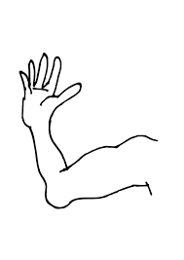
The different parts of the ___________________

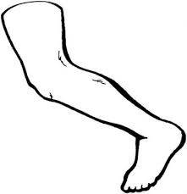

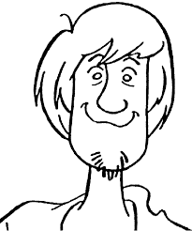

Oral comprehension.
Name :

Listen and draw.

He has got a square face with small green eyes, a small pointed nose and a big mouth.
He has got big ears, freckles and short curly brown hair.

He is medium size. He has small arms with small hands, long legs and big feet.

His name is Edward.

The parts of the body.

https://www.google.com/search?client=firefox-b&biw=1205&bih=672&tbm=isch&sa=1&ei=ZdZ7XJGrL7uO1fAPwd6DaA&q=parts+of+the+body+activities&oq=parts++activities&gs_l=img.3.0.0i7i30l10.17630.18940..21759...0.0..0.70.386.6......1....1..gws-wiz-img.......0i19j0i7i30i19.Bbym0l5aDsw#imgrc=EO_fthxtXeaP0M:

Let's play « Who is it ? »

Is it a boy / a girl ?

Has he / she got glasses ?
hair ?
black skin ?
a beard ?
a moustache ?
a hat ?
a cap ?
earrings
blond hair ?

I think it is …..

Who starts ?
It's your turn.
We have finished.
I won.


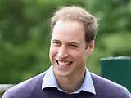
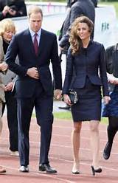

Prince William and
his wife kate Middleton.




Michelle Obama and her husband
Barack Obama.

He is tall and slim. He has got short, straight fair hair and blue eyes. His name is …......................

She is tall and slim. She has got mid long straight black hair and black eyes.

Her name is …...............

She is tall and slim. She has got long curly dark hair. Her name is …........................................

He is tall and slim. He has got short, dark hair. His name is ….........................

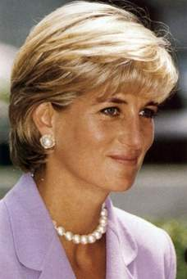



Write the adjectives of personalty which correcpond to the illustrations.

sporty shy / timid curious talkative naughty funny helpful / caring lazy friendly / nice / kind hard-working intelligent / bright / clever jealous

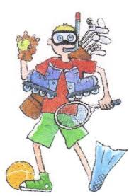
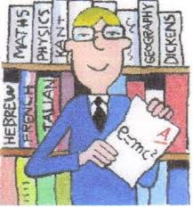
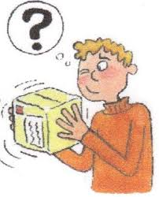
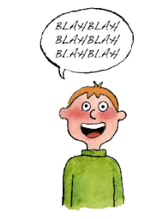


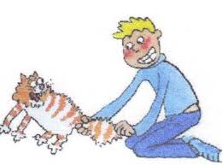
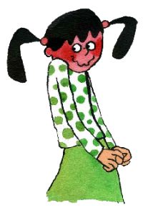

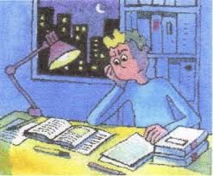
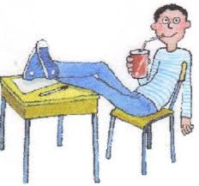
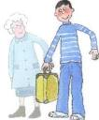
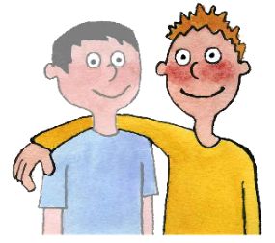

Read the sentences and complete with an adjective.
1 Steve eats a lot, he is …..........
2 Sandra doesn't like working, she is …..........
3 Tony loves doing sport, he is ….........
4 Bob is not a very good boy, he is often violent with his friends, he is …................
5 kate's grandmother often gives her presents and money, she is …..............
6 Philip often helps his parents at home, he is ….........
7 Mary often makes jokes, she is …...........
8 Becky always works and revises her lessons seriously, she is …..........
9 Alison always has very good results at school, she is …....................
10 Ted is never happy, he never laughs, he is …………………………..

Personality.

Augustus Gloop is  Violet Beauregarde is  Veruca Salt is  Mike Teavee is  Charlie Bucket is | competitive  kind  greedy  spoilt  sporty  nervous  pleasant  unpleasant | because she is never satisfied.  because he always eats.  because he always plays violent video games.  because she does a lot of sport.  because she always has what she wants.  because he often helps his family.  because she always has what she wants

Personality.

Augustus Gloop is  Violet Beauregarde is  Veruca Salt is  Mike Teavee is  Charlie Bucket is | competitive  kind  greedy  spoilt  sporty  nervous  pleasant  unpleasant | because she is never satisfied.  because he always eats.  because he always plays violent video games.  because she does a lot of sport.  because she always has what she wants.  because he often helps his family.  because she always has what she wants  because she often gives orders to her parents.

Imagine some more activities the characters of Charlie and the Chocolate Factory always, often, rarely or never do.
 | always / often | rarely / never
Augustus Gloop
Violet Beauregarde
Veruca Salt
Mike Teavee
Charlie Bucket

Read the sentences and complete with an adjective.
1 Steve eats a lot, he is …..........
2 Sandra doesn't like working, she is …..........
3 Tony loves doing sport, he is ….........
4 Bob is not a very good boy, he is often violent with his friends, he is …................
5 kate's grandmother often gives her presents and money, she is …..............
6 Philip often helps his parents at home, he is ….........
7 Mary often makes jokes, she is …...........
8 Becky always works and revises her lessons seriously, she is …..........
9 Alison always has very good results at school, she is …....................
10 Ted is never happy, he never laughs, he is …………………………..

Read the sentences and complete with an adjective.
1 Steve eats a lot, he is …..........
2 Sandra doesn't like working, she is …..........
3 Tony loves doing sport, he is ….........
4 Bob is not a very good boy, he is often violent with his friends, he is …................
5 kate's grandmother often gives her presents and money, she is …..............
6 Philip often helps his parents at home, he is ….........
7 Mary often makes jokes, she is …...........
8 Becky always works and revises her lessons seriously, she is …..........
9 Alison always has very good results at school, she is …....................
10 Ted is never happy, he never laughs, he is …………………………..

Read the sentences and complete with an adjective.
1 Steve eats a lot, he is …..........
2 Sandra doesn't like working, she is …..........
3 Tony loves doing sport, he is ….........
4 Bob is not a very good boy, he is often violent with his friends, he is …................
5 kate's grandmother often gives her presents and money, she is …..............
6 Philip often helps his parents at home, he is ….........
7 Mary often makes jokes, she is …...........
8 Becky always works and revises her lessons seriously, she is …..........
9 Alison always has very good results at school, she is …....................
10 Ted is never happy, he never laughs, he is …………………………..
Pick out the verbs from the sentences.

Remark : in the present the verb has an « S » in the 3rd person singular.

Read the sentences and complete with a verb in the present.
1 Steve ……………….. a lot, he is greedy.
2 Sandra never ………………. seriously, she is lazy.
3 Tony ……………….. a lot of sport, he is sporty.
4 Bob is violent, he often ……………….. with his friends, he is naughty.
5 kate's grandmother often ……………….. her presents and money, she is generous.
6 Philip often ……………….. his parents at home, he is helpful.
7 Mary often ……………….. jokes, she is funny.
8 Becky always ……………….. and ……………….. her lessons seriously, she is hard-working.
9 Alison always ……………….. very good results at school, she is bright.
10 Ted is never happy, he never ……………….., he is boring.

Read the sentences and complete with a verb in the present.
1 Steve ……………….. a lot, he is greedy.
2 Sandra never ………………. seriously, she is lazy.
3 Tony ……………….. a lot of sport, he is sporty.
4 Bob is violent, he often ……………….. with his friends, he is naughty.
5 kate's grandmother often ……………….. her presents and money, she is generous.
6 Philip often ……………….. his parents at home, he is helpful.
7 Mary often ……………….. jokes, she is funny.
8 Becky always ……………….. and ……………….. her lessons seriously, she is hard-working.
9 Alison always ……………….. very good results at school, she is bright.
10 Ted is never happy, he never ……………….., he is boring.

Read the sentences and complete with a verb in the present.
1 Steve ……………….. a lot, he is greedy.
2 Sandra never ………………. seriously, she is lazy.
3 Tony ……………….. a lot of sport, he is sporty.
4 Bob is violent, he often ……………….. with his friends, he is naughty.
5 kate's grandmother often ……………….. her presents and money, she is generous.
6 Philip often ……………….. his parents at home, he is helpful.
7 Mary often ……………….. jokes, she is funny.
8 Becky always ……………….. and ……………….. her lessons seriously, she is hard-working.
9 Alison always ……………….. very good results at school, she is bright.
10 Ted is never happy, he never ……………….., he is boring.

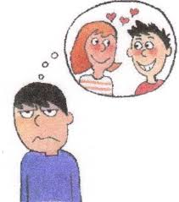

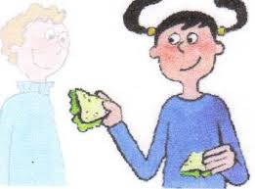

Intermediate test.
(Physical description + personality and habits)

1) Write a paragraph about Kate's physical appearance. / 15 pts

________________________________________________________________________________
________________________________________________________________________________

________________________________________________________________________________
________________________________________________________________________________

________________________________________________________________________________

2) Write a paragraph about Kate's personality and imagine her habits. / 20 pts

(2 different adjectives) (2 different adjectives)

In your work you will use :
- 4 different frequency adverbs (adverbes de fréquence : toujours, souvent, rarement, jamais).

- 6 different adjectives minimum to express Kate's personality.

- 8 different verbs minimum to express Kate's habits (habitudes)
________________________________________________________________________________

________________________________________________________________________________
________________________________________________________________________________

________________________________________________________________________________
________________________________________________________________________________

________________________________________________________________________________

________________________________________________________________________________
________________________________________________________________________________

________________________________________________________________________________
________________________________________________________________________________

Nom :  Etre capable de décrire quelqu'un physiquement, de parler de sa personnalité et de ses habitudes. | / 30pts (coef 2)
Description physique  vocabulaire  verbes | / 8 pts  / 2 pts
Personalité et habitudes  vocabulaire  correction de la langue | personnalité / 6 pts  habitudes / 8 pts  conjugaison / 2 pts  adverbes de fréquence / 2 pts  syntaxe + déterminants + pronoms / 2 pts
Malus : orthographe / soin

Nom :  Etre capable de décrire quelqu'un physiquement, de parler de sa personnalité et de ses habitudes. | / 30pts (coef 2)
Description physique  vocabulaire  verbes | / 8 pts  / 2 pts
Personalité et habitudes  vocabulaire  correction de la langue | personnalité / 6 pts  habitudes / 8 pts  conjugaison / 2 pts  adverbes de fréquence / 2 pts  syntaxe + déterminants + pronoms / 2 pts
Malus : orthographe / soin
Correction tâche intermédiaire (physical description, personality + habits).

Kate is a long nose, neck, hand.

Kate's is tall.

She have big foot.

Kate have got a long, curly hair and a ginger haire.

Kate's has got long hair ginger hair wavy hair eyes.

Kate's is a girls.

Kate a green eyes and ginger hair.

Kate is fat and eyes green have nose is long and long hair red.

She has got a grand foot. She is grand.

Kate's is medium size. She the wavy ginger long hair. She is tall.
And face carré, long noz.

She as got a mouth, two arms, ten fingers and two hands.

Kate is small and fat. And has got a long feets.

Kate is red long hair, a green eyes, a skare face.

Kate has got a freckles and a ginger hair.

He is fat and small. Her feet are plump.

She has got grenn eyes, her foot is big.

She is a medium size. She has got a long féats.

She is helpful. She always gives orders to her family and she never sets the table.

She is intelligent. She never reads.

She never goes horse-riding.

Kate often does sport.

She often sleeps.

Kate is often makes jokes.

Make sentences with the words from the grid.

Helen  Jerry  Bob and his brother | is  are | bossy  nice  generous  greedy  hard-working  boring  lazy  sporty  helpful | he  she  they | always  often  rarely  never | gives presents to his family.  do their homework seriously.  gives orders to her friends.  sleeps and watches TV in his bedroom.  go running.  laughs or smiles.  phones his grandparents.  tidy their bedrooms and set the table.  eats a lot.  helps his parents.  visit their grandparents.

Look at the illustrations and write the correct type of houses from the list :
a castle a cottage a detached house a farm a flat a semi detached house a terraced house


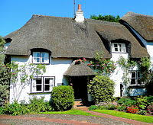



Look at the illustrations and write the correct place of residence from the list :
a big city the countryside a small village the seaside

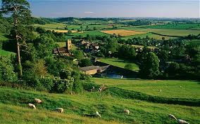

Flash test :
(personality + habits)
Write about the people's personalities from the information in the grid and imagine their habits using frequency adverbs. In a second paragraph you will write about your personality and your habits expressing « très », « assez » and « un peu ».

In your work you will use :
- 7 different words to express people's personalities
- 7 different verbs
- 4 different frequency adverbs
- 3 different words to express degrees (très assez un peu)

________________________________________________________________________________
________________________________________________________________________________

________________________________________________________________________________
________________________________________________________________________________

________________________________________________________________________________
________________________________________________________________________________

________________________________________________________________________________
________________________________________________________________________________

________________________________________________________________________________
________________________________________________________________________________

________________________________________________________________________________
________________________________________________________________________________

Name : | Je suis capable de parler de la personnalité et des habitudes.  / 25 ( coef 2)
personalité | / 4 pts
degré « très » « assez » « un peu » | / 3 pts
verbs | / 7 pts
conjugaison | / 5 pts
adverbs | / 4 pts
syntaxe | / 2 pts
Malus : Soin / orthographe

 | personalities | habits
Kate
Philip
Mary and Sandra
Tony
Me | +++  ++  +

 | personalities | habits
Kate
Philip
Mary and Sandra
Tony
Me | +++  ++  +

Identity | Jack 12 American
Family | 1 brother ( Steve) 2 sisters (Sandra and Mary)  Father (firefighter) Mother ( teacher)
Pets | 1 dog (lolly) 2 cats ( Tom Jerry)
Place of residence | Small village countryside  medium size cottage ( 6 rooms : 3 bedrooms)  small garden
Physical description | Short wavy blond hair / green eyes  tall / plump  small round nose  square face  freckles
Personality | Generous helpful funny
Habits | Always / often :  Never rarely :
 | surfing cooking
 | playing music hiking
 | reading
 | gardening dancing

Complete the sentences with verbs.
1 Peter …................. in the suburbs of London.
2 Sandra …................. 2 brothers.
3 Philip and his brother …................. tennis.
4 Peter …................. generous with his friends.
5 Kate …................. Australian.
6 Paul …................. 2 dogs.
7 Mr and Mrs Stevenson …................. Canadian.
8 James …................. in a big detached house.
9 There …................. a big garden.

10 Patrick and his family…................. at the seaside.
11 There …................. 8 rooms.
12 Tom's grandparents …................. in a semi detached house.
13 Fred and his family …................. 2 cats.
14 Tony …................. 10 years old.
15 Cindy and her sister …................. freckles.
16 Mary …................. a round face.
17 Jack and his friend Mike …................. 12 years old.
18 Harry …................. surfing.
19 William and his brother Charles …................. blue eyes.
20 Mr Harris …................. an architect.
21 Dave and his brother …................. funny.
22 Becky and her friend Rebecca …................. helpful.
23 Alice …................. tall and slim.
24 Chris …................. rowing and hiking.
25 John …................. in an housing estate in a detached house with a medium size garden.

