Hello everybody !
I am Jack, Jack Callahan but my friend call me « Titch » because I am quite small for my age
(I am 12). I am scottish. I am from a small village called Neyland. I have got green eyes and short, straight, ginger hair. I am funny and very generous with my family.
I have got one sister, Dot, that is short for Dorothy. She is 16 years old and she goes to college. She is nice but a little grumpy. My sister is tall and a little chubby, she has got short, curly, dark hair.
I am mad about martial arts, it is super. I am small but I am strong. I like fish and chips, chicken with fried potatoes but I don't like vegetables much except peas. I hate cheese and brocolis. I like hamsters I loves dogs but I hates snakes and rats. I do a lot of sport. I like playing cricket with my friends, I play in the school team.
In my freetime, I love going to the cinema with my friends an d playing music but I detest reading and doing my homework.
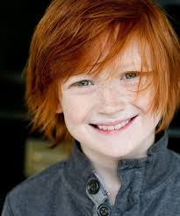
That's all for the moment. Bye everybody !!

Complete the grid with information from the text about the boy.
Identity :
- first name
- family name
- age
- nationality
- origin (place of residence)
Physical description
- eyes
- hair
- height (taille)
- built (corpulence)
- physical quality
Brothers and sisters
(note down some information)
Pets
Likes
sport
food
animals
activities

Dislikes
sport
food
animals
activities
Activities Habits
Complete the sentences with a ver from the list.

am have got live is has got lives are

1 Fred ……………….. tall and slim.
2 Kate ……………….. grey eyes.
3 I ……………….. long curly dark hair.
4 Jerry ……………….. in New York.
5 Bob and his father ……………….. brown eyes.
6 I ……………….. in Normandy.
7 William ……………….. from London.
8 Andrew ……………….. short, frizzy, dark ahir.
9 Mary ……………….. from Australia.
10 David and Jack ……………….. in Sydney.
11 Tony ……………….. American.
12 I ……………….. average size.
13 Ailson and her sister ……………….. English.
14 Peter and his family ……………….. Canadian.

Complete the sentences with a ver from the list.

am have got live is has got lives are

1 Fred ……………….. tall and slim.
2 Kate ……………….. grey eyes.
3 I ……………….. long curly dark hair.
4 Jerry ……………….. in New York.
5 Bob and his father ……………….. brown eyes.
6 I ……………….. in Normandy.
7 William ……………….. from London.
8 Andrew ……………….. short, frizzy, dark ahir.
9 Mary ……………….. from Australia.
10 David and Jack ……………….. in Sydney.
11 Tony ……………….. American.
12 I ……………….. average size.
13 Ailson and her sister ……………….. English.
14 Peter and his family ……………….. Canadian.

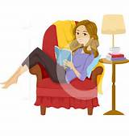
Dear friend,
Let me introduce myself. My name is Becky. I am 14 years old. I am Welsh, I live in the capital Cardiff. I like playing music, I often play the piano and the guitar. I also like sport, I love ice-skating and horse riding but I don't like playing rugby. I sometimes go to the ice rink with my friend Helen and I go horse riding every week on Saturdays.
I have got mid long straight ginger hair and green eyes. I am average height and slim. I look like
my mother because she is slim too but I don't look like my father because he has got blue eyes and blond hair.
I have got 2 brothers, John and Paul. They are in year 7. They are twins, they were born in 2008. I love my brothers. They are twins but they don't look like each other. John is tall and slim and Paul is
a little plump and medium size. Paul is sporty, he loves doing sport, he plays tennis, rugby and cricket but John is very quiet, he prefers listening to music or playing music. He plays the violin.
My mother is super, she is cool and funny. Her name is Sandra. She is 38 and she works in a hospital.
My father is 40, he is a bus driver. I love him but he is sometimes strict but he is caring.
In my family we all love animals. We have got 2 dogs, 3 cats and 1 guinea pig.
At week ends, I often go to the cinema with my friends, my brother Paul often plays tennis with his friend Patrick and John often plays music or reads. On Sundays, we sometimes go to the beach with our parents when it is sunny.
Complete with information from the text.

The girl :  name, age, nationality  place of residence, brothers and sisters  likes and dislikes, hobbies / habits, physical description | Becky 14 Welsh Cardiff 2 brothers  hobbies : piano and guitar  likes : playing music ice-skating horse-riding sport  dislikes : playing rugby  habits / activities : ice-rink with her friend Helen horse-riding every week on Saturdays  mid long straight ginger hair green eyes average height slim like her mother
The girl's family :  names, ages, likes, dislikes, qualities, faults, jobs, hobbies / habits,  physical description ... | Brothers : Paul and John in year 7 9 twins  Mother : Sandra 38  Father : 40  Likes : Paul / sport John / listening to music playing music  Hobbies / activities / habits : Paul /rugby tennis cricket  John / the violin  Mother : Sandra  Physical description:John / tall and slim Paul a little plump / medium size brothers different Mother / slim like Becky  Father / blue eyes and blond hair  Qualities and faults :  Mother : cool and funny  Paul : sporty  John : quiet  Father : strict and caring  Activities : go to the beach on Sundays (sunny)  Likes : animals  Jobs : mother / works in a hospital father : bus driver  sometimes beach on Sundays with her family
Pick out the words which express an activity.
Ice-skating horse-riding playing music playing cricket playing rugby

playing tennis playing the piano playing the violin playing football

playing the guitar

Pick out the words which express a quality or a fault.

Pick out the children's habits.

Pick out the words which express an activity.

Pick out the words which express a quality or a fault.

Pick out the children's habits.

Look at the illustrations and write the corresponding activities from the list.

going to the cinema cooking playing video games horse riding cycling dancing
reading roller skating playing football / soccer watching TV playing music drawing
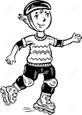


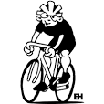

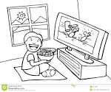

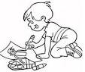
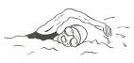

listening to music playing the piano swimming going shopping


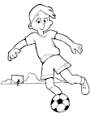
1 2 3 4

5 6 7 8

9 10 11 12

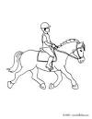


13 14 15 16

1 listening to music 2 watching TV 3 reading 4 playing football / soccer

5 playing video games 6 drawing 7 swimming 8 going to the cinema

9 roller skating 10 going shopping 11 cycling 12 playing music
13 horse riding 14 dancing 15 playing the piano 16 cooking

Complete the grid with activities you like, you love or you don't like, you hate doing.

 |  | 

Complete the grid with activities you like, you love or you don't like, you hate doing.

Qualities and faults.

Note down the appropriate words.

curious lazy talkative jealous generous naughty helpful / caring selfish funny

shy / timid hard working intelligent friendly / nice sporty

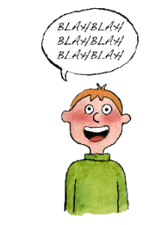
1 _____________ 2 _____________ 3 ______________ 4 ______________
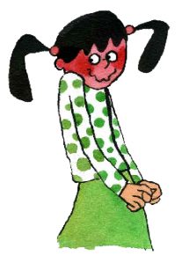
5 _____________ 6 _____________ 7 _________________ 8 _____________

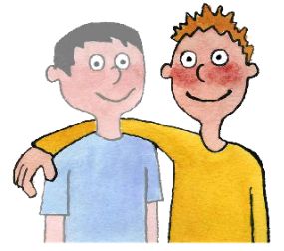
9 _______________ 10 ______________ 11 ______________ 12 _____________

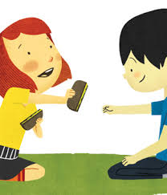

13 ________________ 14 _______________

Qualities and faults (correction).

Note down the appropriate words.

curious lazy talkative jealous generous naughty helpful / caring selfish funny

shy / timid hard working intelligent friendly / nice sporty

1 intelligent 2 curious 3 sporty 4 talkative
5 funny 6 shy / timid 7 jealous 8 naughty

9 lazy 10 helpful / caring 11 hard working 12 friendly / nice

13 generous 14 selfish

Answer the questions.
1 Do you know a person who is funny ?
Yes, my …............... is funny.
No, nobody is funny in my family or among (parmi) my friends.

2 Do you know a person who is lazy ?
3 Do you know a person who is generous ?

4 Do you know a person who is talkative ?

5 Do you know a person who is funny ?

Answer the questions.
1 Do you know a person who is funny ?
Yes, my …............... is funny.
No, nobody is funny in my family or among (parmi) my friends.

2 Do you know a person who is lazy ?
3 Do you know a person who is generous ?

4 Do you know a person who is talkative ?

5 Do you know a person who is funny ?

Written comprehension test.
Dear friend,

Let me introduce myself. My name is Laura Kenwood. I was born on 3rd January 2005 in New York but I live in England more precisely in the capital because my parents are working here for 5 years. We will go back to America then, normally in July 2022.

I have got short, curly, black hair and blue eyes and I am medium size and slim. I look like my father but his eyes are grey, not blue. I am funny and very talkative.

I have got 1 sister, Joanna, she is a bit older than me, she was born in 2003. She is shy, calm and very helpful. She often helps me with my homework because I have some difficulties and she often listens to music or draws in her bedroom.

My mother is 45, she is a journalist. She is a little strict but she is very nice and generous. My mother loves cooking and she is very good at cooking, she is a real « chef ». I like everything she prepares especially chocolate cake and chicken curry.

My father's name is Jack, he is 47. He is a web designer, he is hard working and sporty.
I am sporty too. I play tennis with my father every week, on Saturday afternoons.

In my freetime, I like going to the cinema with my friends and I love going shopping with my mother and my sister.

That's all for the moment. Write me soon to tell me about yourself. I would like to know you !

Bye.

Grille d'évaluation.

Name :
Je suis capable de prélever des informations explicites
Je suis capable de déduire des informations
Je suis capable de prélever des informations de manière précise

Complete the grid with information from the text.
The girl :
her name + her age
her date + place of birth
her nationality
her place of residence
her personality
Likes / dislikes
her hobbies / habits
The girl's sister :
her name + her age
her personality
her hobbies / habits
The girl's mother :
her age
her job
her personality
The girl's father :
his name + his age
his job
his personality

