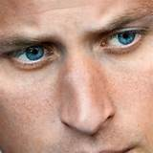
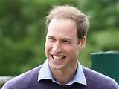
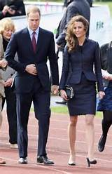
Prince William and
his wife kate Middleton.

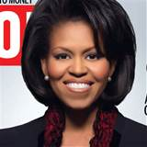
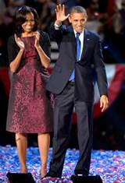
Michelle Obama and her husband
Barack Obama the preseident of
the United States of America.

He is tall and slim. He has got short, straight fair hair and blue eyes. His name is …......................

She is tall and slim. She has got mid long straight black hair and black eyes.
Her name is …...............

She is tall and slim. She has got long curly dark hair. Her name is …........................................

He is tall and slim. He has got short, dark hair. His name is ….........................

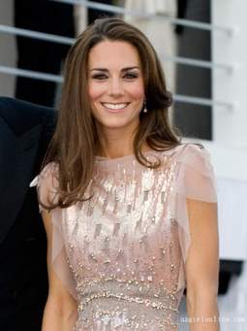
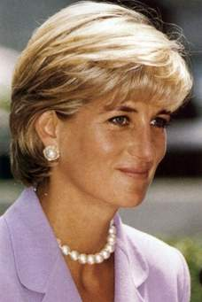

Kate Middleton Lady Diana Barbara Streisand

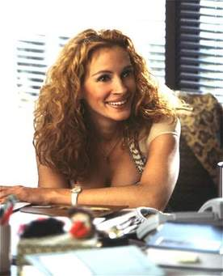
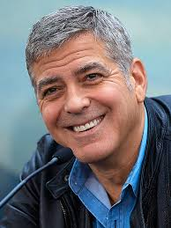
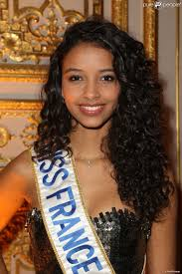
Julia Roberts
George Clooney Flora Coquerelle

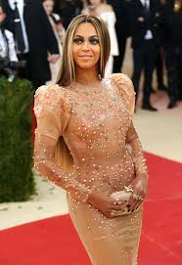
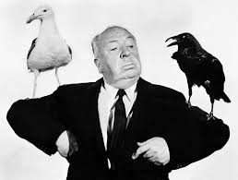
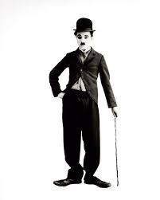
Alfred Hitchcok Charlie Chaplin
Beyonce

