Look at the illustrations and write the corresponding activities from the list.

going to the cinema cooking playing video games horse riding cycling dancing
reading roller skating playing football / soccer watching TV playing music drawing
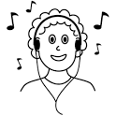
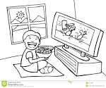
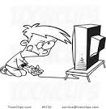
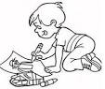
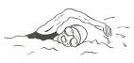

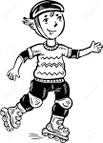

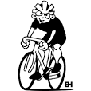

listening to music playing the piano swimming going shopping

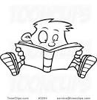
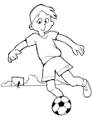
1 2 3 4

5 6 7 8

9 10 11 12

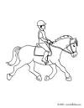
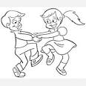

13 14 15 16

1 listening to music 2 watching TV 3 reading 4 playing football / soccer

5 playing video games 6 drawing 7 swimming 8 going to the cinema

9 roller skating 10 going shopping 11 cycling 12 playing music

13 horse riding 14 dancing 15 playing the piano 16 cooking

Complete the grid with activities you like, you love or you don't like, you hate doing.

 |  | 

Complete the grid with activities you like, you love or you don't like, you hate doing.

Vocabulary flash test.

Name :

1 2 3 4

5 6 7 8

9 10 11 12

Write 2 sentences about the activities you , you and the activities

you you .

________________________________________________________________________________
________________________________________________________________________________
________________________________________________________________________________
________________________________________________________________________________

