The time.

Amorce :
Parler de son emploi du temps dire à quelle heure on commence les cours, à quelle heure on termine, à quelle heure on a français /maths etc …. le lundi / le mardi etc ….The time.

Transfert :
- Etre capable de dire et de comprendre l'heure
(l'heure qu'il est / à quelle heure on a rendez vous quelque part ….)
- Etre capable de parler de son emploi du temps

Tâche finale : Etre capable de comprendre et de dire quand et à quelle heure ouvre et ferme un monument ou un lieux public

Step 1 :
Revision numbers 1 59

Step 2 :
What time do you start school on Mondays ?
I start school at 8.25.

eight twenty-five

Practise your comprehension (listen and write)

It's 08:00 It's 10:15 It's 11:40 It's 07:10 It's 09:50 It's 12:45 It's 06:20 It's 04:30

I have Maths at 14:15 on Tuesdays. I start school at 09:30 on Wesdnesdays. I have an appointment at the dentist's tomorrow at 16:15 I have dinner at 19:45 in general.
I start school at 09:30 on Wesdnesdays. I finish my homework at 18:00 in general.
I go to football practise at 17:30 on Wedsnesday afternoons.
I am going to the cinema with my grandmother next Saturday at 15:15

two fifteen = 02:15 / 14:15
two fifteen (am) = 02:15 two fifteen (pm) = 14:15

Practise your comprehension (listen and write)
It's 16:00 It's 18:00 It's 09:00 It's 01:00 It's 22:00 It's 15:00 It's 11:00 It's 20:00
It's 21:00 It's 19:30 It's 07:15 It's 08:20 It's 18:35 It's 22:50 It's 11:35 It's 23:55

In general, I start school at 08:25 and I finish at 16:55.
On Wednesdays I finish school at 12:30.

Oral practise (say the times above).

Step 3 :
What time is it ? / What is the time ?
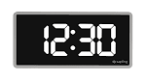
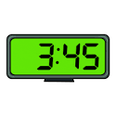
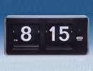
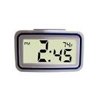
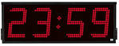
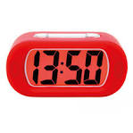
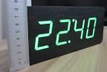

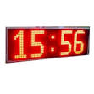
What time is it ? / What is the time ?

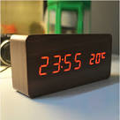

What time is it ? / What is the time ?

Step 4 :
I understand dates and times of appointments

Listen and take notes in your diary.

I have an appointment at the dentist's on the 12th at 18:15

I have a tennis match on the 30th at 14:30

I have an appointment at the hairdresser's on the 20th at 16:45

I am taking my cat to the vet's on the 19th at 1120.

I am taking the train to Paris on the 21st at 12 :30.

I have an appointment at the doctor's with my son on the 22nd at 10 :45.

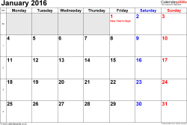

Step 5 :
Opening times.

- Diaporama The tower of London + The London Eye
- Individual practise : The Tower of London.

Oral practise. Express the opening times of Oral practise. Express the opening times of
The Tower of London from the information. The Tower of London from the information.
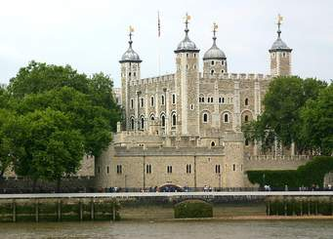
The Tower of London The Tower of London
Opening times. Opening Times

Nov 01 - Feb 28 Nov 01 - Feb 28
Tues – Sat Tues - Sat
09.00 – 16.30 09.00 - 16.30
Sun – Mon Sun - Mon
10:00– 16.30 10.00 – 16.30

Oral practise. Express the opening times of The Tower of London from the information.

The Tower of London
Opening times.

Nov 01 - Feb 28
Tues– Sat
09.00 – 16.30
Sun – Mon
10.00 – 16.30

Complete.

…................. November 1st …................ February 28th, The Tower of London …................. …................. 09:00 and it …................. …................. 16:30 …................. Tuesday …................. Saturday. On …................. and on …................. it …................. …................. 10:00 and it …................. …................. 16:30.
Oral practise. Express the opening times of The Tower of London from the information.

The Tower of London
Opening times.

Nov 01 - Feb 28
Tues – Sat
09.00 – 16.30
Sun – Mon
10.00 – 16.30

Complete.

…................. November 1st …................ February 28th, The Tower of London …................. …................. 09:00 and it …................. …................. 16:30 …................. Tuesday …................. Saturday. On …................. and on …................. it …................. …................. 10:00 and it …................. …................. 16:30.

Oral practise. Express the opening times of The Tower of London from the information.

The Tower of London
Opening times.

Nov 01 - Feb 28
Tues – Sat
09.00 – 16.30
Sun – Mon
10.00 – 16.30

Complete.

…................. November 1st …................ February 28th, The Tower of London …................. …................. 09:00 and it …................. …................. 16:30 …................. Tuesday …................. Saturday. On …................. and on …................. it …................. …................. 10:00 and it …................. …................. 16:30.
Oral practise. Express the opening times of Oral practise. Express the opening times of
The Tower of London from the information. The Tower of London from the information.
The Tower of London The Tower of London
Opening times. Opening Times

Nov 01 - Feb 28 Nov 01 - Feb 28
Tues – Sat Tues - Sat
09.00 – 16.30 09.00 - 16.30
Sun – Mon Sun - Mon
10:00– 16.30 10.00 – 16.30

Oral practise. Express the opening times of Oral practise. Express the opening times of
The Tower of London from the information. The Tower of London from the information.
The Tower of London The Tower of London
Opening times. Opening Times

Nov 01 - Feb 28 Nov 01 - Feb 28
Tues – Sat Tues - Sat
09.00 – 16.30 09.00 - 16.30
Sun – Mon Sun - Mon
10:00– 16.30 10.00 – 16.30

Let's practise ! Listen and take notes.

Practise 1 :
Madame Tussaud's Museum.

From April 5th to September 23rd Madame Tussaud's Museum in london opens at 10 and it closes at 17:00 everyday except on Mondays because it is closed .

Ap 5 – Sept 23

10:00 – 17:00

Thurs : closed

Practise 2 :
The Steam Museum.

From February 1st to June 30th The Steam Museum in london opens at 10 and it closes at 17:00 from Tuesday to friday .

On Saturdays and on Sundays it opens at 9:30 up to 18:00. On Modays, The Steam Museum is closed.

Feb 01 – June 30
Tues – Fri
10:00 – 17:00

Sat – Sun
9:30 – 18:00

Mon : closed

