Name : Form :

1) Listen and complete the clocks. / 2,5

:
:
:
:
:

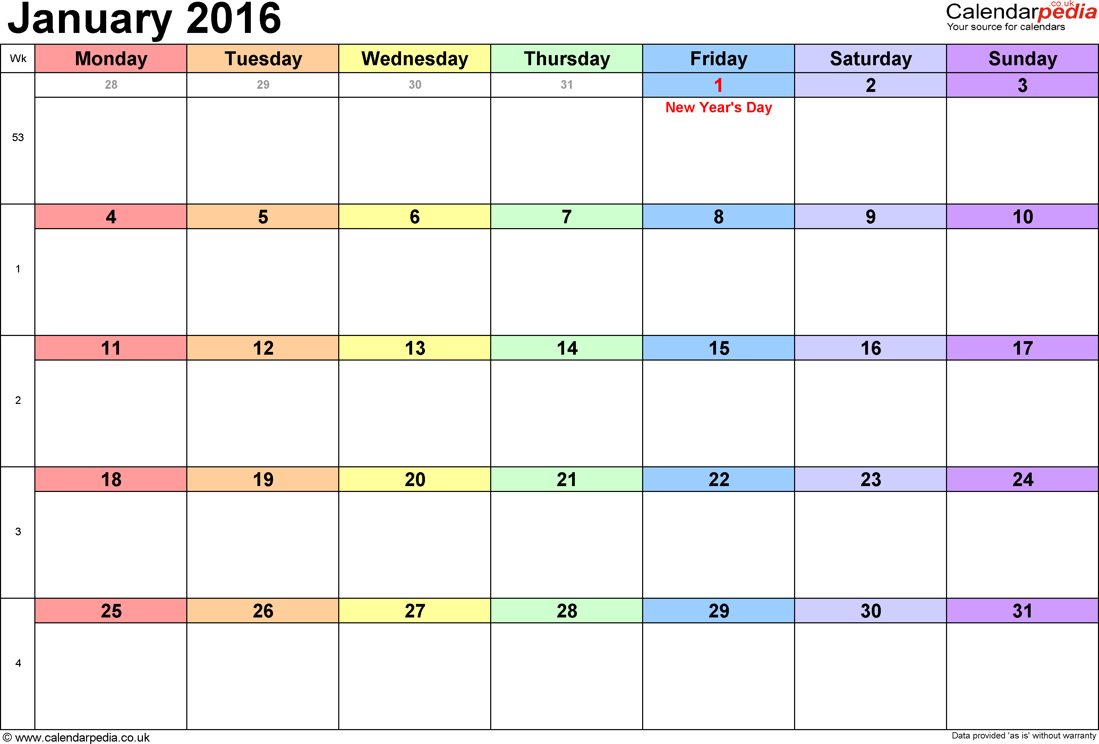
2) Listen and take notes in the diary. / 7,5

3) Listen and take notes about the opening times of Cadbury World. / 10
(Cadbury World is a chocolate factory in England)



Opening times

Mark /20

Name : Form :

1) Listen and complete the clocks. / 2,5

:
11:40
20:30
19:15
15:45
21:55

2) Listen and complete the following diary. / 7,5
I have a rugby match on the 20th at 13:30
I have an appointment at the doctor's on the 25th at 18:45
I am going to the hair dresser's at 11:15 on the 23rd

2) Listen and take notes about the opening times of Cadbury World. / 10
(Cadbury World is a chocolate factory in England)
Opening times

From January 25th to February 24th Cadbury World will open at 10:15 and it will close at 3:45 from Monday to Friday. On Saturdays and on Sundays it will open at 09:30 up to 16:00.

