What is the weather like, today ?

It’s cold It’s sunny It’s hot It’s rainy It’s cloudy It’s windy


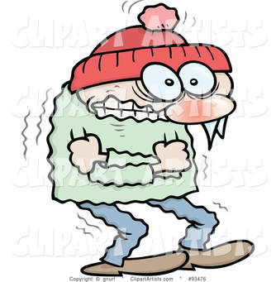

It’s rainy It’s cold It’s cloudy


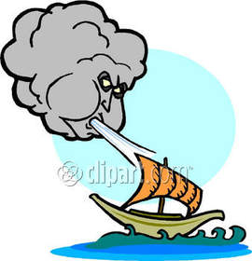


It’s hot It’s windy

It’s snowing It’s sunny

It’s very very / extremely cold (++++) = It’s frezzing
It’s very cold ( +++)
It’s quite cold (++)
It’s a little cold (+)

It’s a little hot = It’s warm

My favourite weather is when it is ……… and ……..

What ……………………………………………………………., today ?

It’s cold It’s sunny It’s hot It’s rainy It’s cloudy It’s windy

Name :

W__________________________________________________________?

___________________________________ ___________________________________
_____________________________________ __________________________________
___________________________________ ___________________________________

Today, _________________________________________________________________________________

Name :

W__________________________________________________________?

___________________________________ ___________________________________
_____________________________________ __________________________________
___________________________________ ___________________________________

Today, _________________________________________________________________________________

Name :

the is today weather what like?
___________________________________________________________________________ ?

It's cloudy
It's rainy
It's hot
It's cold
It's windy
It's sunny
It's cloudy
It's rainy
It's hot
It's cold
It's windy
It's sunny

It's cloudy
It's rainy
It's hot
It's cold
It's windy
It's sunny

It's cloudy
It's rainy
It's hot
It's cold
It's windy
It's sunny

It's cloudy
It's rainy
It's hot
It's cold
It's windy
It's sunny

It's cloudy
It's rainy
It's hot
It's cold
It's windy
It's sunny

Today, _______________________________________________________________________

