It's carnival !!

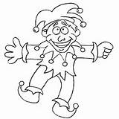
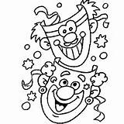
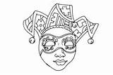

Try to find out the words.
The code corresponds to the order of the letters in the alphabet.

__ __ __ __ __ __ __ __ __ __ __ __ __
13 1 19 11 19 16 1 14 3 1 11 5 19

__ __ __ __ __ __ __ __ __ __ __ __ __ __
6 12 15 1 20 19 3 15 19 20 21 13 5 19

__ __ __ __ __ __ __ __ __ __ __ __
16 1 18 1 4 5 19 13 21 19 9 3

__ __ __ __ __
4 1 14 3 5

__ __ __ __ __ __ __ __ __ __ __ __ __ __
19 20 18 5 5 20 6 5 19 20 9 22 1 12



