Mardi Gras or carnival is a festive season. It normally takes place in february. Mardi Gras is "Fat Tuesday" in English. It is a day of carnival, when people dress up (put on costumes), have parades, dance, eat, drink, and stay up late.
Mardi Gras is celebrated in many places around the world: New Orleans, Louisiana, USA; Rio de Janeiro, Brazil (where it is called Carnaval); Nice, France; and others.
The world's largest carnival celebration is held in Rio de Janeiro, Brazil with more than 2 million people on the street each day during the carnival.
The traditional New Orleans Mardi Gras colors are purple, green and gold.

Complete the sentences with information from the text.
Mardi Gras in English is …………….
The date of Mardi Gras is …………….
The activities for Mardi Gras are …………………………………………
In ………………………….. carnival is very big.
………………………… people go in the streets to celebrate carnival.
Purple, green and gold are the colors of carnival in ……………………...

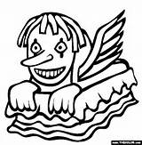
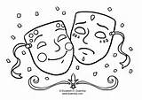

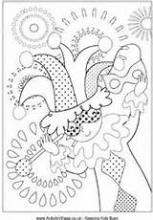

It's carnival !!

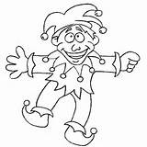

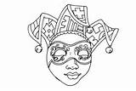

Try to find out the words.
The code corresponds to the order of the letters in the alphabet.

__ __ __ __ __ __ __ __ __ __ __ __ __
13 1 19 11 19 16 1 14 3 1 11 5 19

__ __ __ __ __ __ __ __ __ __ __ __ __ __
6 12 15 1 20 19 3 15 19 20 21 13 5 19

__ __ __ __ __ __ __ __ __ __ __ __
16 1 18 1 4 5 19 13 21 19 9 3

__ __ __ __ __
4 1 14 3 5

__ __ __ __ __ __ __ __ __ __ __ __ __ __
19 20 18 5 5 20 6 5 19 20 9 22 1 12

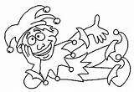

Mardi Gras Alphabet Code | Mardi Gras Page  Alphabet Theme Page

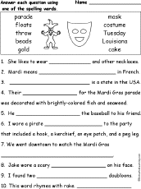

It's Carnival Season
Parades, costumes, music and a whole lot of merriment... that is Carnival! Carnival is a festive season which occurs just before Lent, usually during January and February. Carnival involves public celebrations, parades, school festivals, masquerades, street parties, games, food and oodles of fun and lively entertainment. The world's largest carnival celebration is held in Rio de Janeiro, Brazil with more than 2 million people on the street each day during the carnival. However, many countries worldwide have large, popular celebrations, such as Carnival of Venice, Italy, Belgium, Bolivia, Canada, Trinidad, Tobago, Spain Carnivals and the world famous Mardi Gras celebration in New Orleans, Louisianna (USA).
Read more at http://www.hellokids.com/t_1347/carnival-for-children#DYDxqRR49UqMXeBJ.99

