Look at the illustrations and complete the sentences.

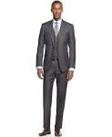

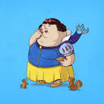
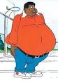
1 2 3 4

1 He is …... and ….....

2 She is …..... and …....

3 She …..... …..... and ….....

4 He …..... …..... and ….....

Look at the photos and write a complete description of Queen Elizabeth.



